|  |  |  |  |  |  |  |  |
| --- | --- | --- | --- | --- | --- | --- | --- |
| Submission Coversheet | | | |  |  |  |  |
|  |  |  |  |  |  |  |  |
| **Student ID Number** | ANI18457381 | | | | | | |
| **Programme Title** | Computing Technologies Degree | | | | | | |
| **Module Title** | Web Development | | | | | | |
| **Module Code** (listed on Moodle and in LTAFP) | [QAC020C153A](https://partnerships.moodle.roehampton.ac.uk/course/view.php?id=489) | | | | | | |
| **Module Convenor** | Ekereuke Udoh | | | | | | |
| **Coursework Title** | Coursework1: JS Wedding Planners | | | | | | |
| **Academic Declaration:**  Students are reminded that the electronic copy of their essay may be checked, at any point during their degree, with Turnitin or other plagiarism detection software for plagiarised material. | | | | | | | |
| **Word Count** | 8511 | | | **Date Submitted** | | **10/12/2018** | |
|  |  | | |  | |  | |

Table of Contents

Introductory information 4

Web Site Design 4

Introduction 4

Site Map Schematic 4

Webpage Wireframes 5

Home Page Desktop Wireframe 6

Home Page Tablet Wireframe 6

Home Page Mobile Wireframe 8

Portfolio Page Desktop Wireframe 10

Portfolio Page Tablet Wireframe 11

Portfolio Page Mobile Wireframe 12

Packages Page Desktop Wireframe 15

Packages Page Tablet Wireframe 16

Packages Page Mobile Wireframe 17

Services Page Desktop Wireframe 19

Services Page Tablet Wireframe 20

Services Page Mobile Wireframe 21

Contact Page Desktop Wireframe 23

Contact Page Tablet Wireframe 24

Contact Page Mobile Wireframe 25

Color Schemes and Style Patterns 27

Web Page Accessibility 27

Design Principles 31

Availability and Accessibility 31

Readability 31

Repetition 32

Contrast 33

Proximity 33

Development: 33

CSS validation 33

File - main.css 33

File - main.css 34

Html validation 35

File – index.html 35

File – portfolio.html 35

File – packages.html 36

File – services.html 36

File – contact.html 37

Web page UI elements and their related code 37

Body structure 37

Header Element 38

Main menu element 40

Footer Element 43

Go to Top Button 44

Home Page Content 45

Portfolio Page Content 48

Packages Page Content 49

Services Page Content 50

Contact Page Content 53

Mobile media query 61

Tablet media query 66

Global Css file 68

Testing and validation: 69

Browser compatibility and Device responsiveness 69

Chrome Compatibility and Responsiveness Test 70

Opera Compatibility and Responsiveness Test 72

Firefox Compatibility and Responsiveness Test 75

Test Table 77

Deployment: 83

XAMPP Deployment 83

Live hosting Deployment 88

Appendix A 90

References 90

# Introductory information

Js Wedding Planners is a web project defined and designed by and for dTech Limited, a very well-known UK top company, in the communications industry. The web site was created to extend their business and for reaching out new online customers, but also to provide a way of contact for their existing clients.

The project is meant to provide useful information about the company’s services like: photography, cakes, venue booking, wedding planning, transport and florist but also to bring out their portfolio, their standard packages and a way to contact them.

# Web Site Design

## Introduction

The web project is consisted of five pages: home, portfolio, packages, services and contact. Each page has its own unique responsive design and a common template for the header, content and footer.

## Site Map Schematic

As presented in Figure 1 the site map shows the list of the web pages and the hierarchical relations between them.

Every page can access any other page, including themselves, with the main menu represented by the black arrow lines and can also go to their neighboring pages, represented in the figure below by the red arrow lines, with the help of the left and right buttons in the header area.

Having multiple options for the browsing of the site ensures that it is going to have a good impact on the client’s user experience by giving him choices on any type of device thus adding mobility on phones and tablets.

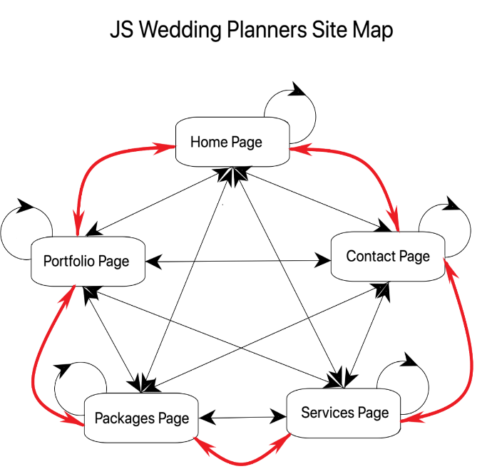

Figure 1

## Webpage Wireframes

The JS Wedding Planners web page wireframes represent a rough approximation sketch to help the client and the developer have a better image and understanding of the hole schematic of the project.

Each page is divided into three sub-wireframes categories represented by the type of the device it is portraying: desktop, tablet or mobile. Not all wireframes will have adnotated text because it will be redundant to do so. Only newly introduced objects will be explained in the sketches below.

### Home Page Desktop Wireframe

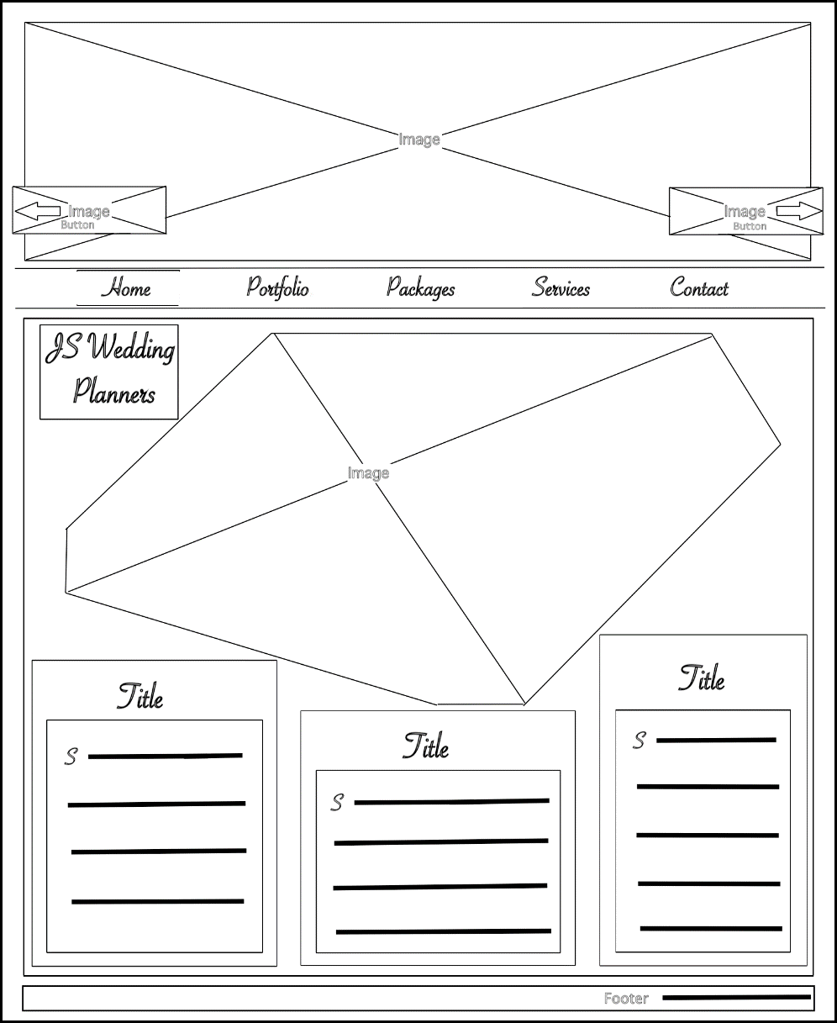

Secondary Image

Link Image represented as a button for accessing the Contact Page

Link Image represented as a button for accessing the Portfolio Page

Brand name text/ intersects with secondary image

Text box with title and paragraph/ intersects with secondary image/uses local font for the title and the first character of the paragraph

Text box with title and paragraph/ does not intersect with secondary image/uses local font for the title and the first character of the paragraph

Text box with title and paragraph/ intersects with secondary image/uses local font for the title the first character of the paragraph

Footer section containing information like copyright and name

Menu selection, highlighted with a thin top and bottom border

Main menu highlighted with a thin top and bottom border/ on hovering over the list’s elements the menu item is highlighted with a contrasting background color

Content section differentiating from the body with a lighter background color

The body container highlighted with a darker background color

Main Page Image

Figure 2

### Home Page Tablet Wireframe

The home page is compatible with the tablet resolutions, resizing its elements accordingly. No major changes occur in comparison with the desktop variant, apart from having bigger, left and right, buttons

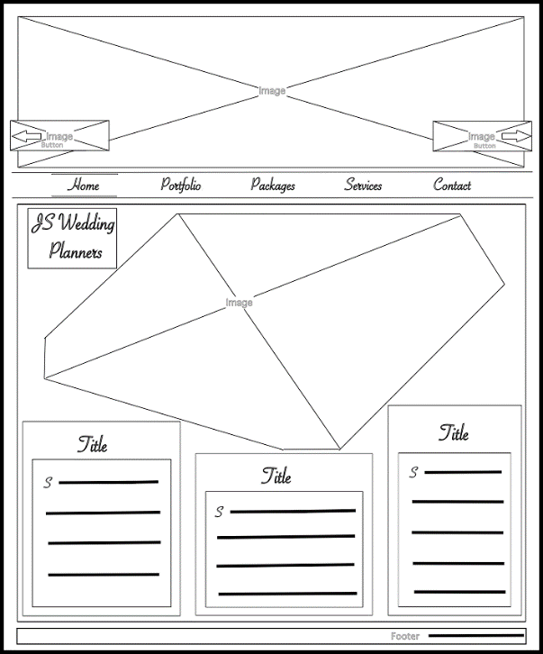

Figure 3

### Home Page Mobile Wireframe

* Hidden home menu state:

Figure 4

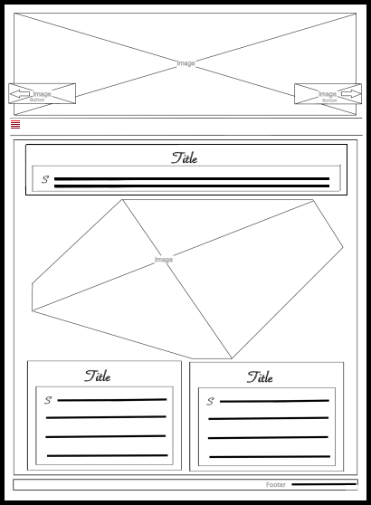

Main menu is hidden on mobile devices/can be viewed in vertical mode when the toggle button is pressed

Toggle button contained by the main menu with the task to show and hide the listed items on mobile devices/ it also highlights the position of the current page by contrasting it’s referenced line out of the five ones into a lighter and brighter color nuance.

Because of the low resolution on mobile devices the middle text box has been moved at the top of the content section.

Because of the low resolution on mobile devices the left text box occupies half of it’s previous desktop container.

Because of the low resolution on mobile devices the right text box occupies half of it’s previous desktop container.

* Visible home menu state:

Figure 5

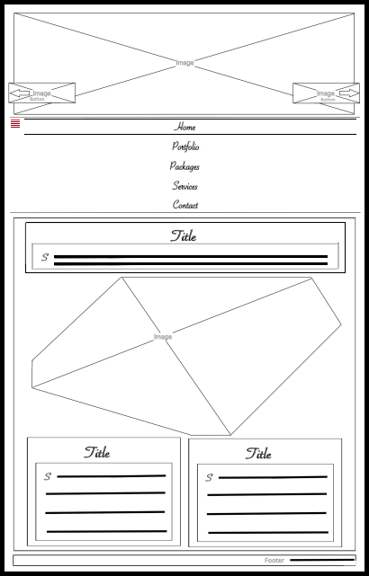

The main menu is shown in vertical mode on mobile devices, after the toggle is pressed/The toggle button mantains its position after it is pressed and the list items are vertically aligned and flow to the right.

Selected menu item highlighted as in the desktop view with a thin top and bottom border.

### Portfolio Page Desktop Wireframe

Figure 6

The content section houses the portfolio gallery/ The gallery is divided into 4 equal collumns

The red paranthesis highlights that the selected subsection is a column consisted of images

Image with no border

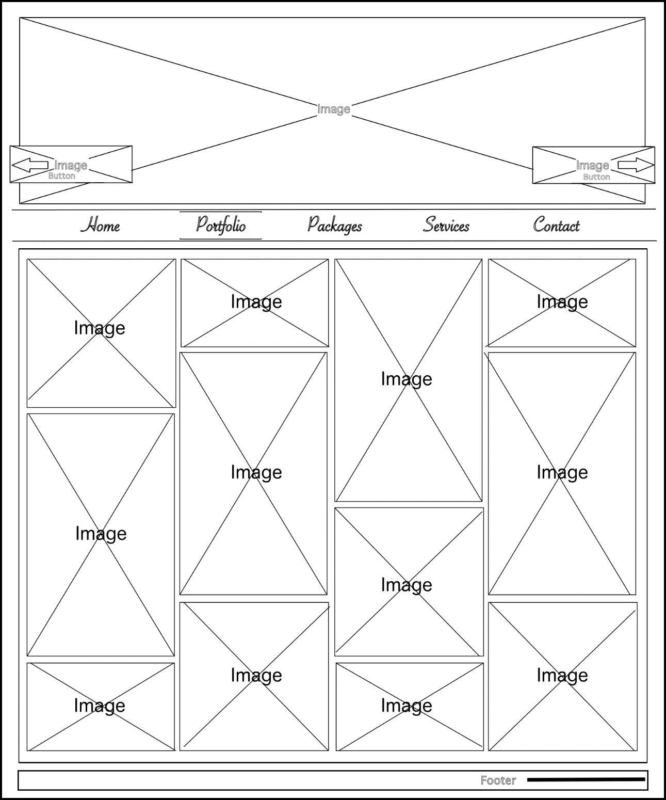

### Portfolio Page Tablet Wireframe

Figure 7

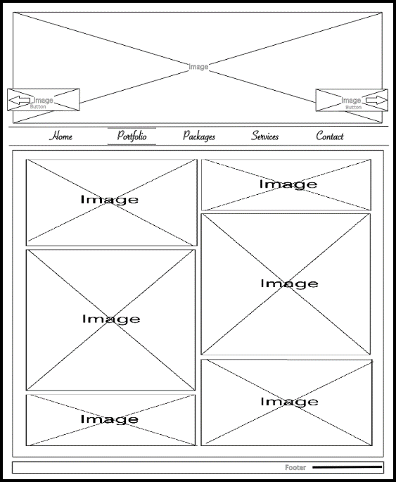

Because of the smaller resolutions on the tablet devices, the gallery resizes to a two columns gallery view

### Portfolio Page Mobile Wireframe

* Hidden portfolio menu state:

Figure 8

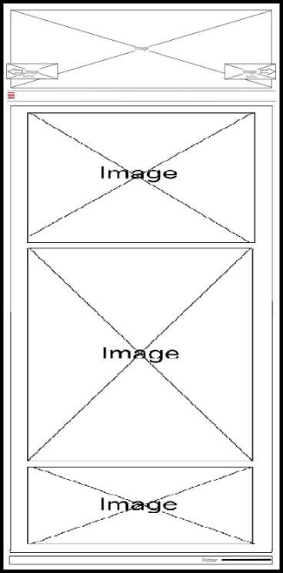

On the mobile devices the content resizes to a one column gallery

* 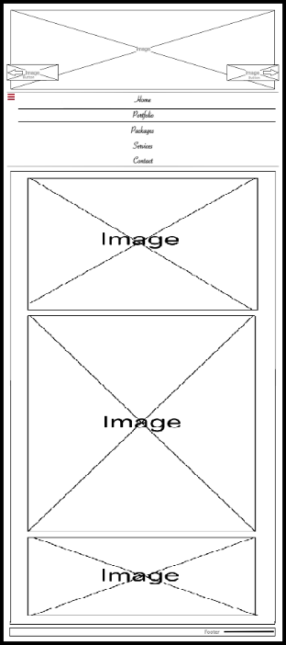Visible portfolio menu state:
* Visible portfolio menu state:

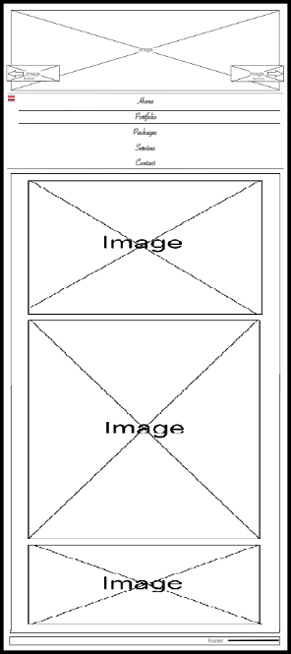

### Packages Page Desktop Wireframe

Figure 9

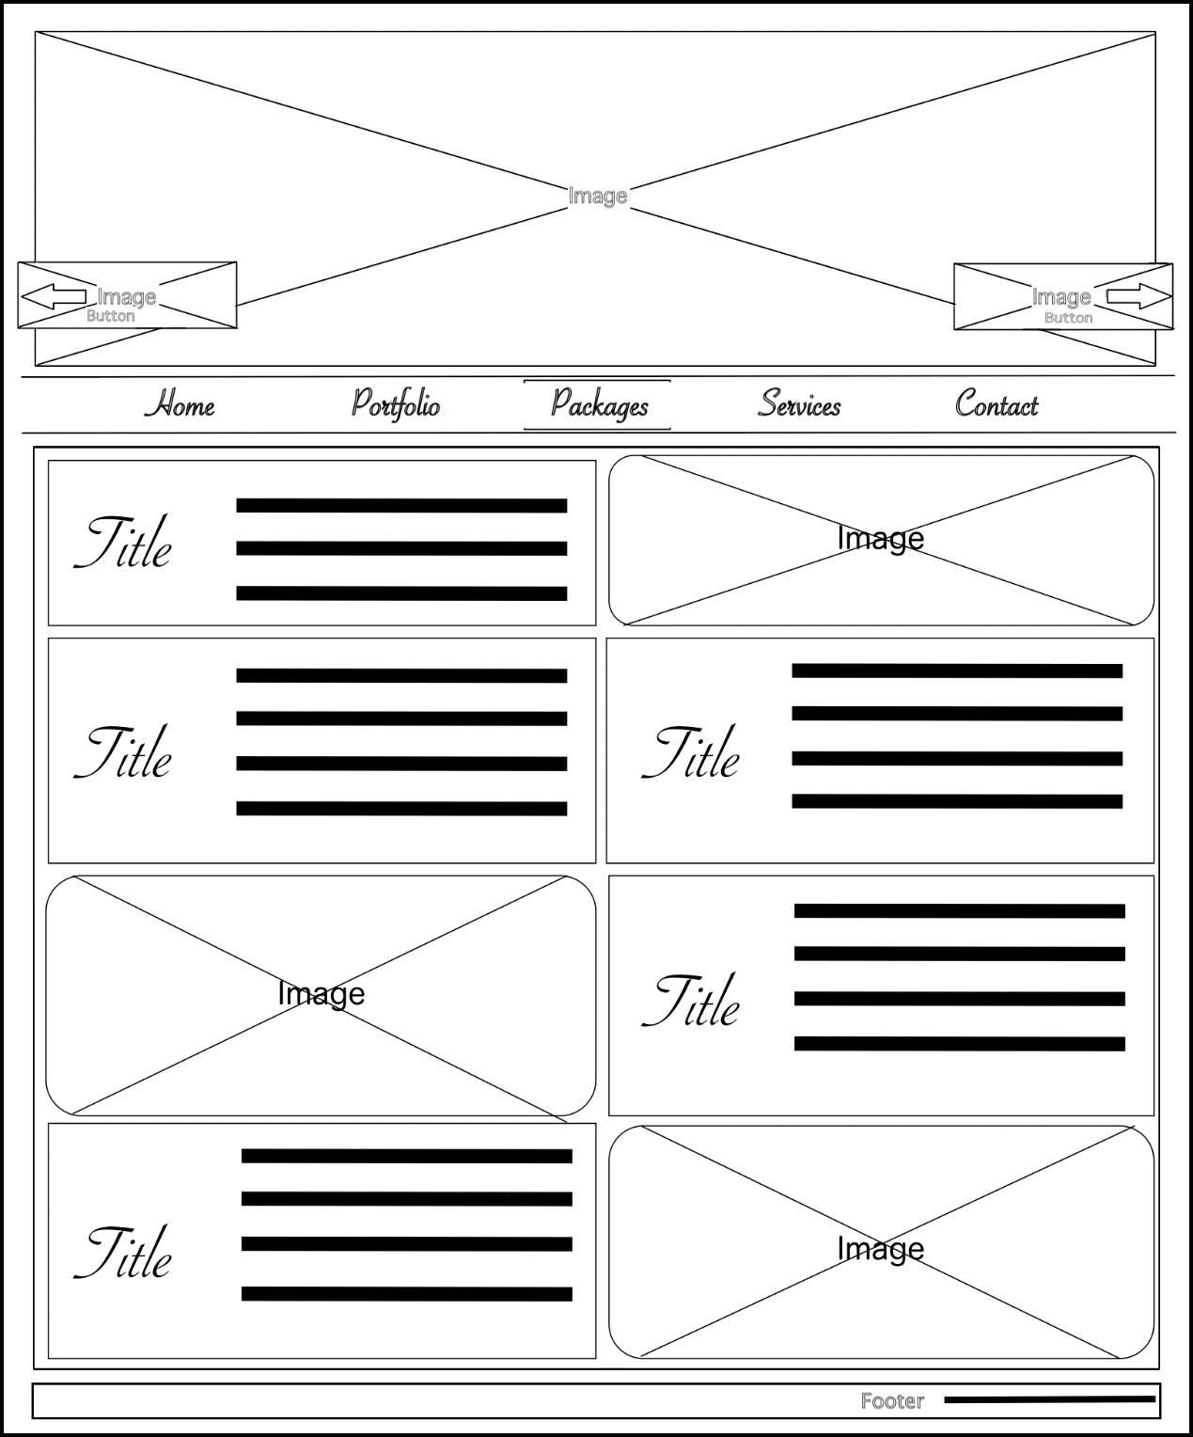

The content section houses the packages offers and some images/ The gallery is divided into 2 equal columns consisting of articles and images

Image with no border and rounded at the corners

Box text with the title floating left and the paragraph right

### Packages Page Tablet Wireframe

Figure 10

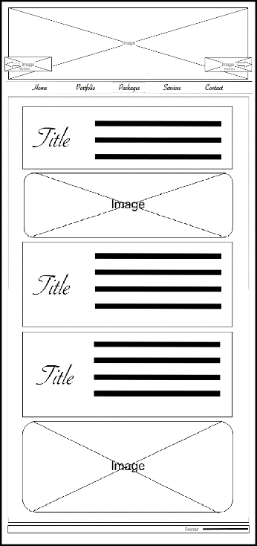

On tablet resolutions the content resizes to one column view and the items are listed in the order their inserted in the html file

### Packages Page Mobile Wireframe

* Hidden packages menu state:

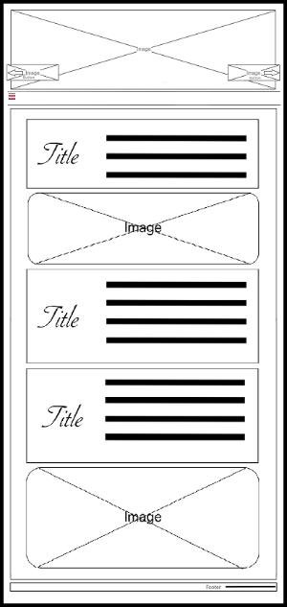

Figure 11

* Visible packages menu state:

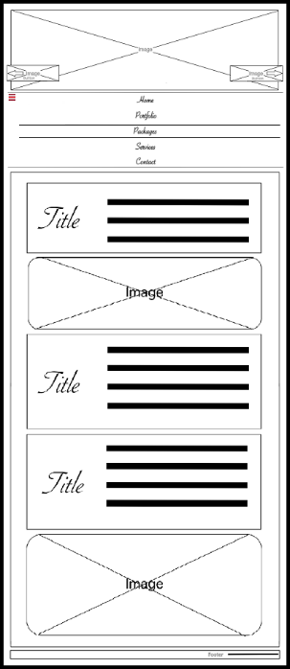

Figure 12

### Services Page Desktop Wireframe

Figure 13

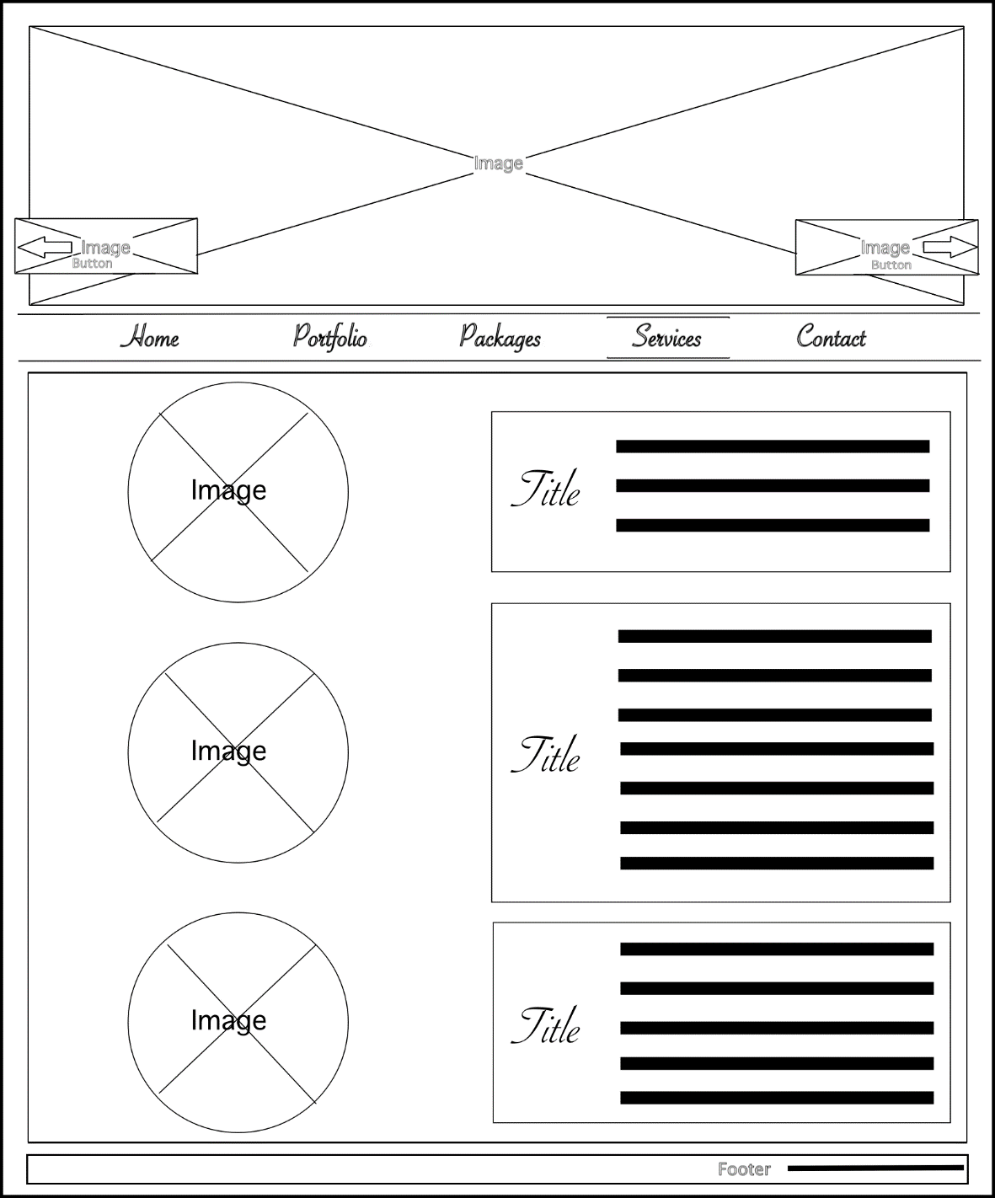

The content is represented by a grid with two columns which contains images on the left and articles on the right

Rounded image with no border

### Services Page Tablet Wireframe

Figure 14

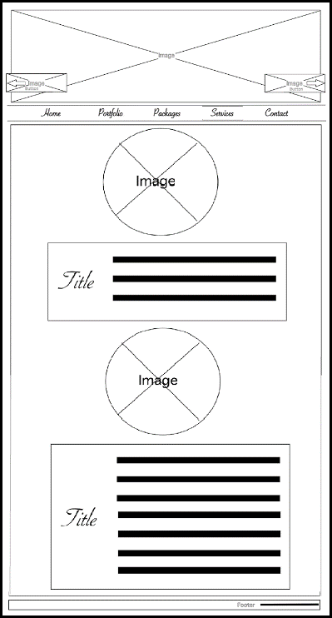

On tablet resolution the content resizes into a grid with one column in which every image is followed by its article

### Services Page Mobile Wireframe

* Hidden services menu state:

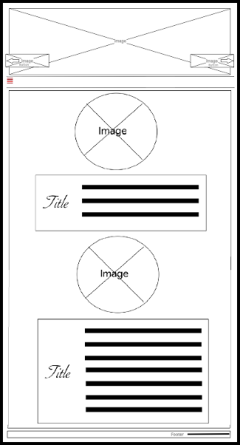

Figure 15

* Visible services menu state:

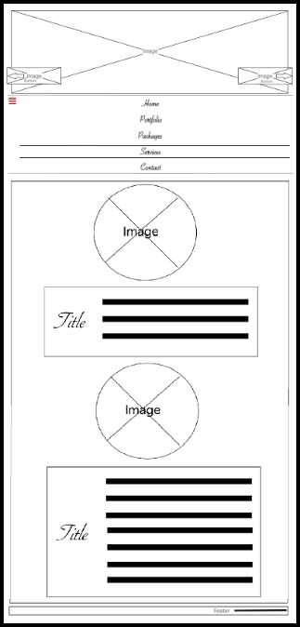

Figure 16

### Contact Page Desktop Wireframe

Figure 17

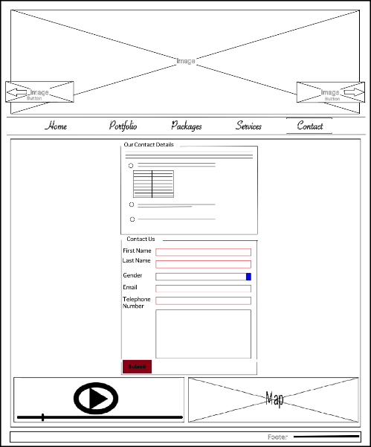

The content houses two centered field-sets and a grid with two columns containing a video and a Bing map

The top field-set represents the contact details of the company.

Introducing paragraph

Unordered list enumerating the multiple contact options

Table containing working hours

Input field for requesting the user’s first name, last name, email and telephone number. The inputs have autofocus and are required with a custom pattern set for each one

Select box containing gender options with default value

Text area with the properties that it is required and has autofocus

Bing map containing the location of the company/ it is set in the left part of a grid with minimal control

Video containing info on how to reach the location of the company/ It used as a second option in case the map service doesn’t work/ It is set with controls and error message

Labels paired with their input

Form data for submitting info about the client/ The display property is set as table

Button used to submit data through a post request

### Contact Page Tablet Wireframe

Figure 18

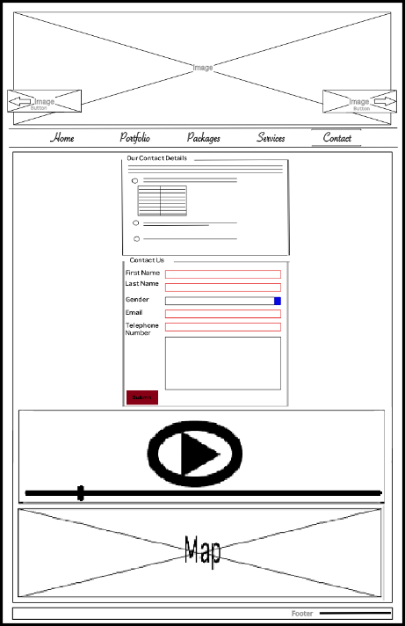

On the tablet resolutions the grid converts to one column putting the video on the first row and the map on the second row

### Contact Page Mobile Wireframe

* Hidden contact menu state:

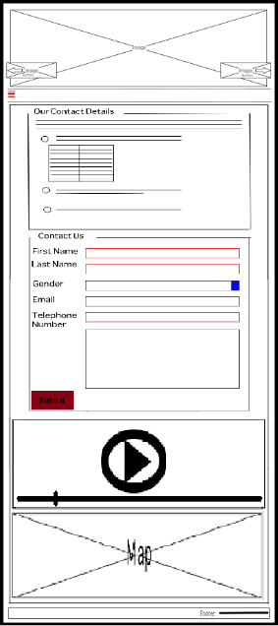

Figure 19

* Visible contact menu state:

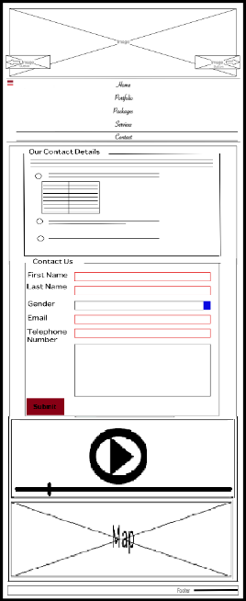

Figure 20

## Color Schemes and Style Patterns

The figure below portrays the chosen color scheme in contrast with the default font family color/size and a custom font for menu/title and start of paragraph.

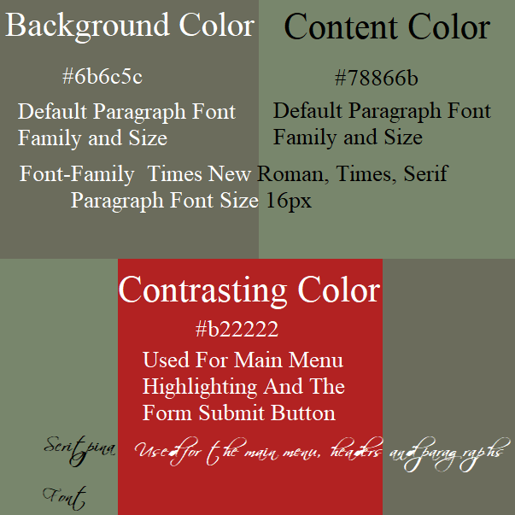

Figure 21

## Web Page Accessibility

* Every page has the html tag language set to English so that it can better assist search engines spiders, page formatting and screen reader technology;
* Every image, input and menu have the alternative and title attributes set to a descriptive text;
* The reading text is set to a minimum font size of 16 pixels, which is a lot higher than the minimum accepted of 12 pixels according to the standards;
* As presented in Figure 21 the contrast between the text and the background color is within the standard for the WCAG 2 level AA which requires a contrast ratio of at least **4.5:1** for normal text and **3:1** for large text;

Figure 22

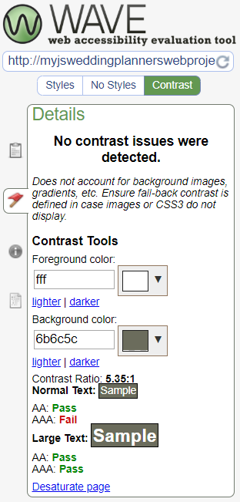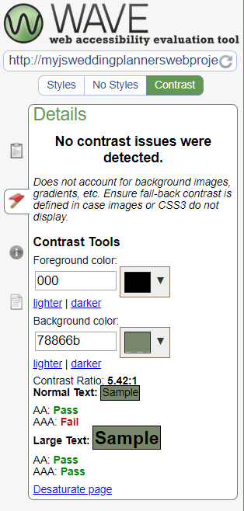

* The pages have been marked up by regions using the header, main and footer tags.
* Headings have been nested by their rank for a better site readability;
* The web pages have been marked up semantically by correctly using tags like nav, article, sections, figures, lists and so on, so that it is reusable and more meaningful to assistive technologies.
* The site was tested for four color blind anomalies, to better understand the impact of the palette scheme chosen for the web page:

1. 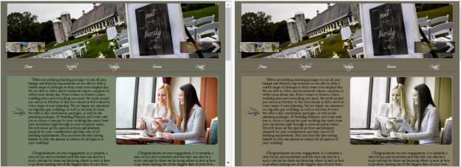Protanopia (red/green color blindness, anomalous red cones):

Figure 23

1. 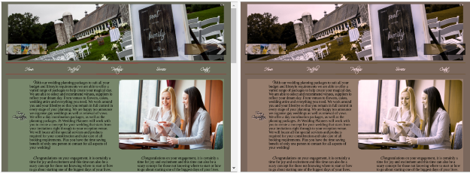Deuteranopia (red/green color blindness, anomalous green cones):

Figure 24

1. 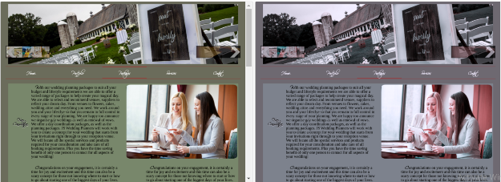Tritanopia (blue/yellow color blindness, anomalous blue cones):

Figure 25

1. Greyscale/achromatopsia (partial or total absence of color vision):

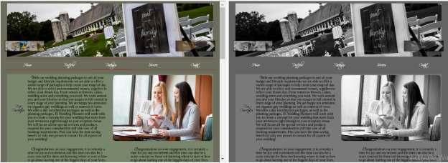

Figure 26

* The pages can be accessed through the main menu or by the left and right header buttons;
* The main menu page selection is highlighted by a top and bottom border over the pages button;
* Scrolling down into the page will automatically show a fixed button in the bottom part of the window giving the option to go at the start of the page;
* The page is responsive on any device and works on almost any new browser, the elements repositioning themselves to suit a better view for the user;
* In mobile mode the main navigation bar transforms into a dropdown menu toggling between visible and hidden through a small button;

* The contact page gives information about the company on how to contact them, and the meaning to contact them through a validated form;
* The contact page displays a Bing Map and a video with the location of the company. The video is small with a size of about 10mb and can be used by the user in case the Microsoft’s Bing Map service fails to respond;
* Validation checks have been set on user input on the contact page in the form area; this is better represented in the development chapter where the code is explained in detail;

## Design Principles

### Availability and Accessibility

* The hosting servers from Hostinger have a 100% uptime and an average of 140ms response time;
* There are no broken links;
* The web site is mobile, tablet and desktop responsive;

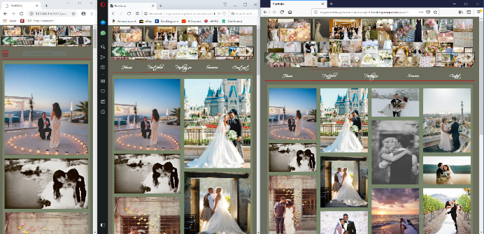

Figure 27

### Readability

Figure 28 proofs that the pages are not overcrowded, easy to read and well defined.

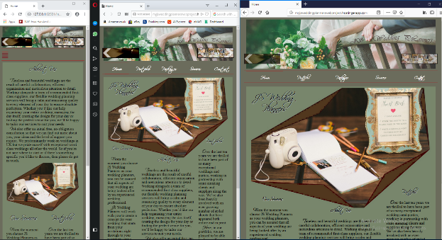

Figure 28

### Repetition

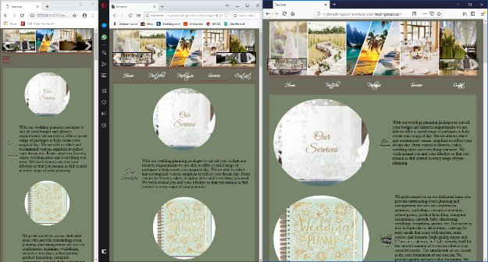

Figure 29

### Contrast

As seen in Figures 27, 28 and 29 the pages have contrasting elements all over the site.

### Proximity

As represented in Figures 27, 28, 29 and 30 the elements are visually grouped, and the color white is present in all pages, for example in the main menu, in the form etc.

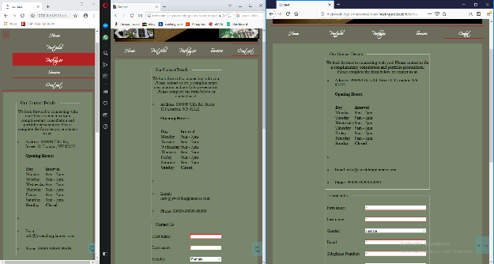

Figure 30

# Development:

## CSS validation

### File - main.css

The main.css file resides in “/assets/css” folder. As presented in Figure 27 the main.css file has passed validation but because the project uses flexbox, flex-wrap and flex it has some warnings for using the “-ms-flexbox”, “-ms-flex-wrap” and “ms-flex” which are vendor extensions needed for compatibility with the Microsoft’s browser.

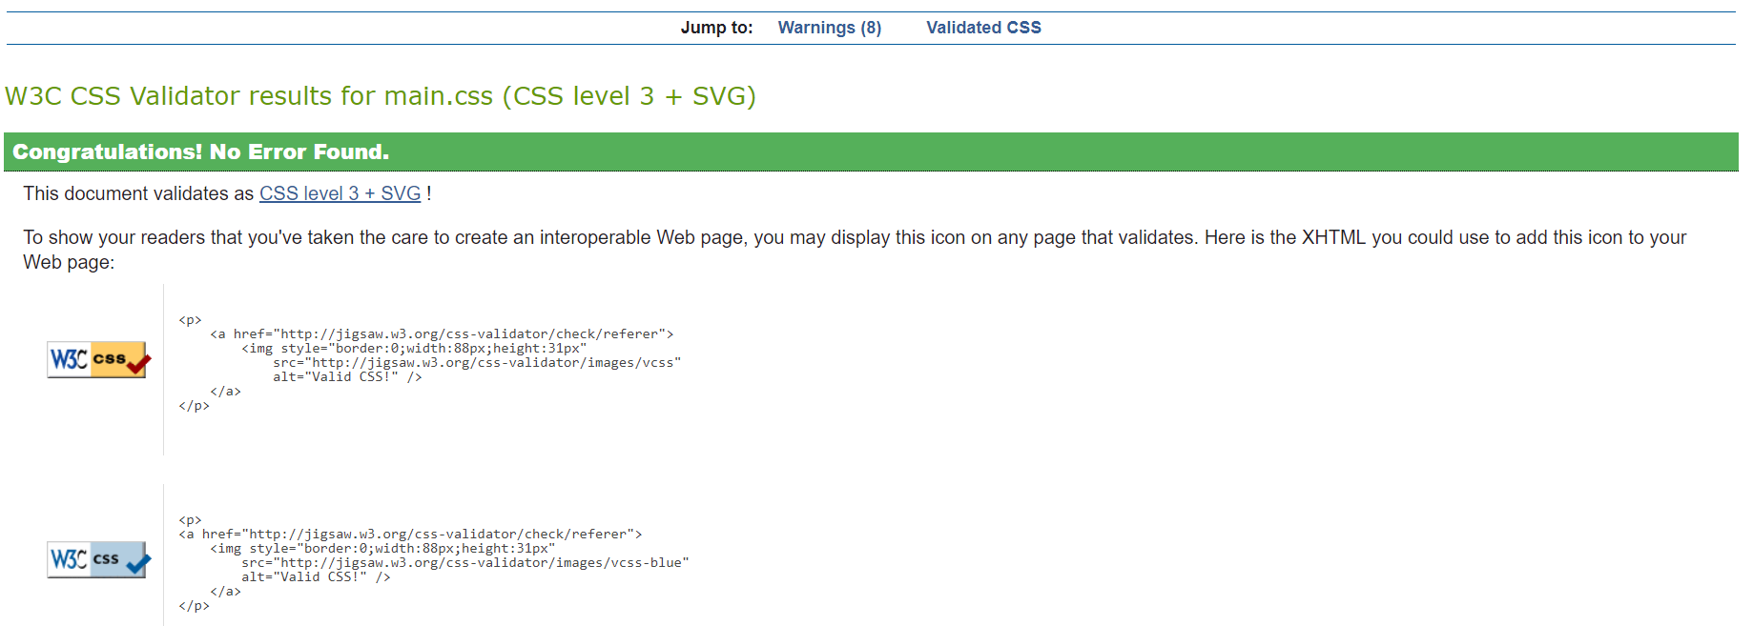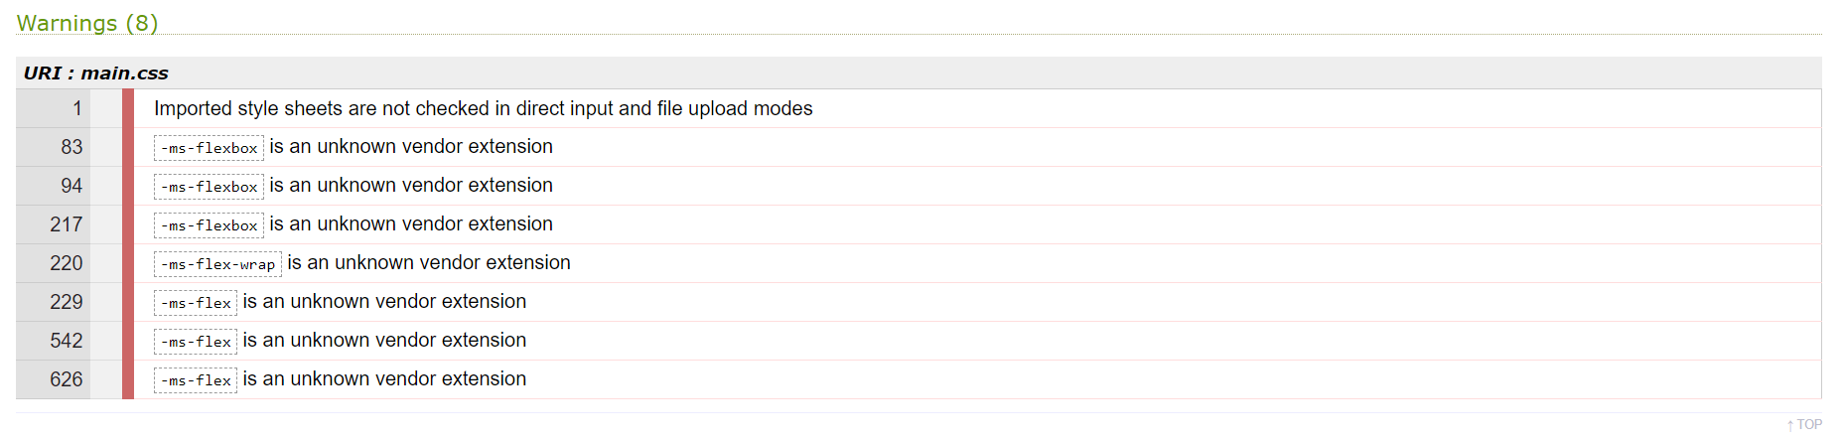

Figure 31

### File - global.css

The global.css file resides in “/assets/css” folder and it has fully passed validation as shown in Figure 28. This file only sets global styles, so it is only natural to have a 100% validation score.

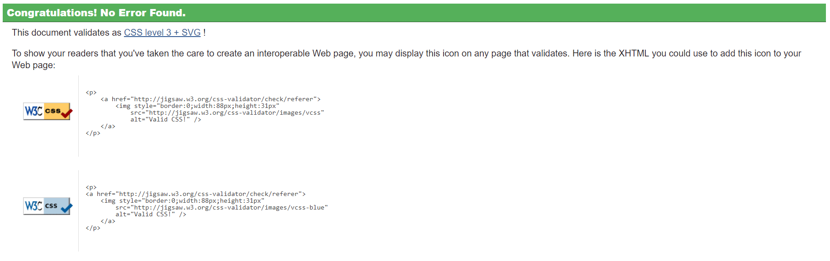

Figure 32

## Html validation

### File – index.html

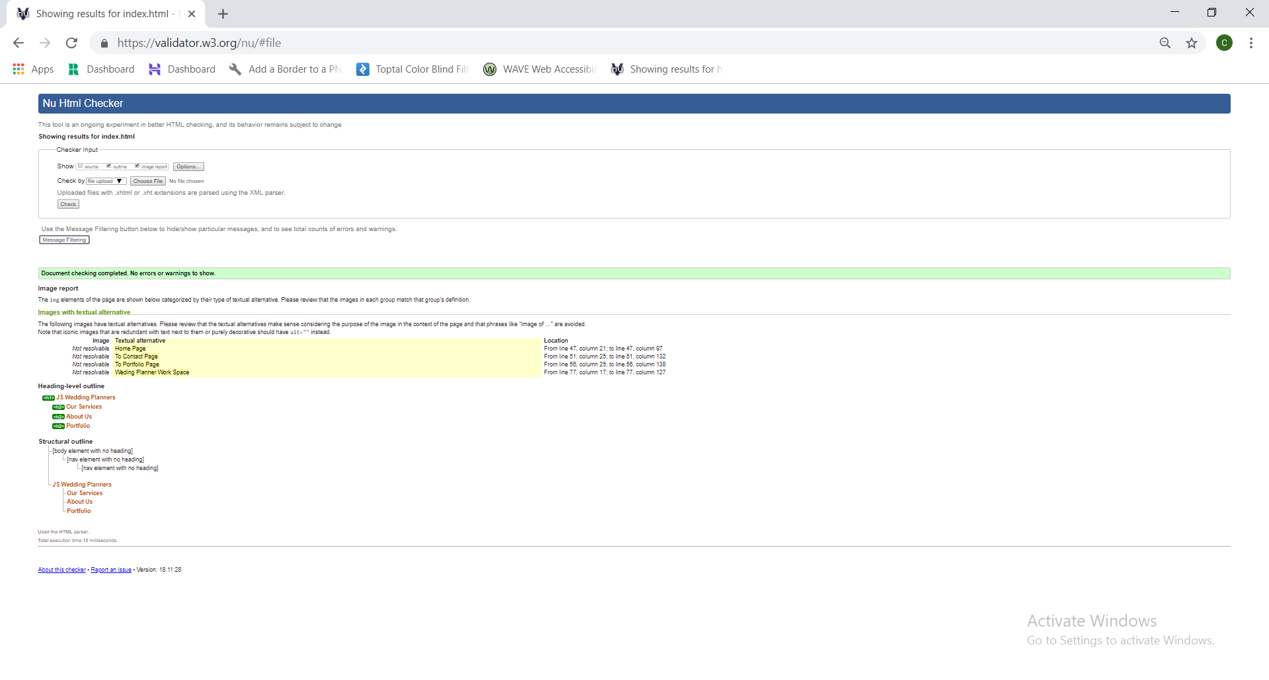

### File – portfolio.html

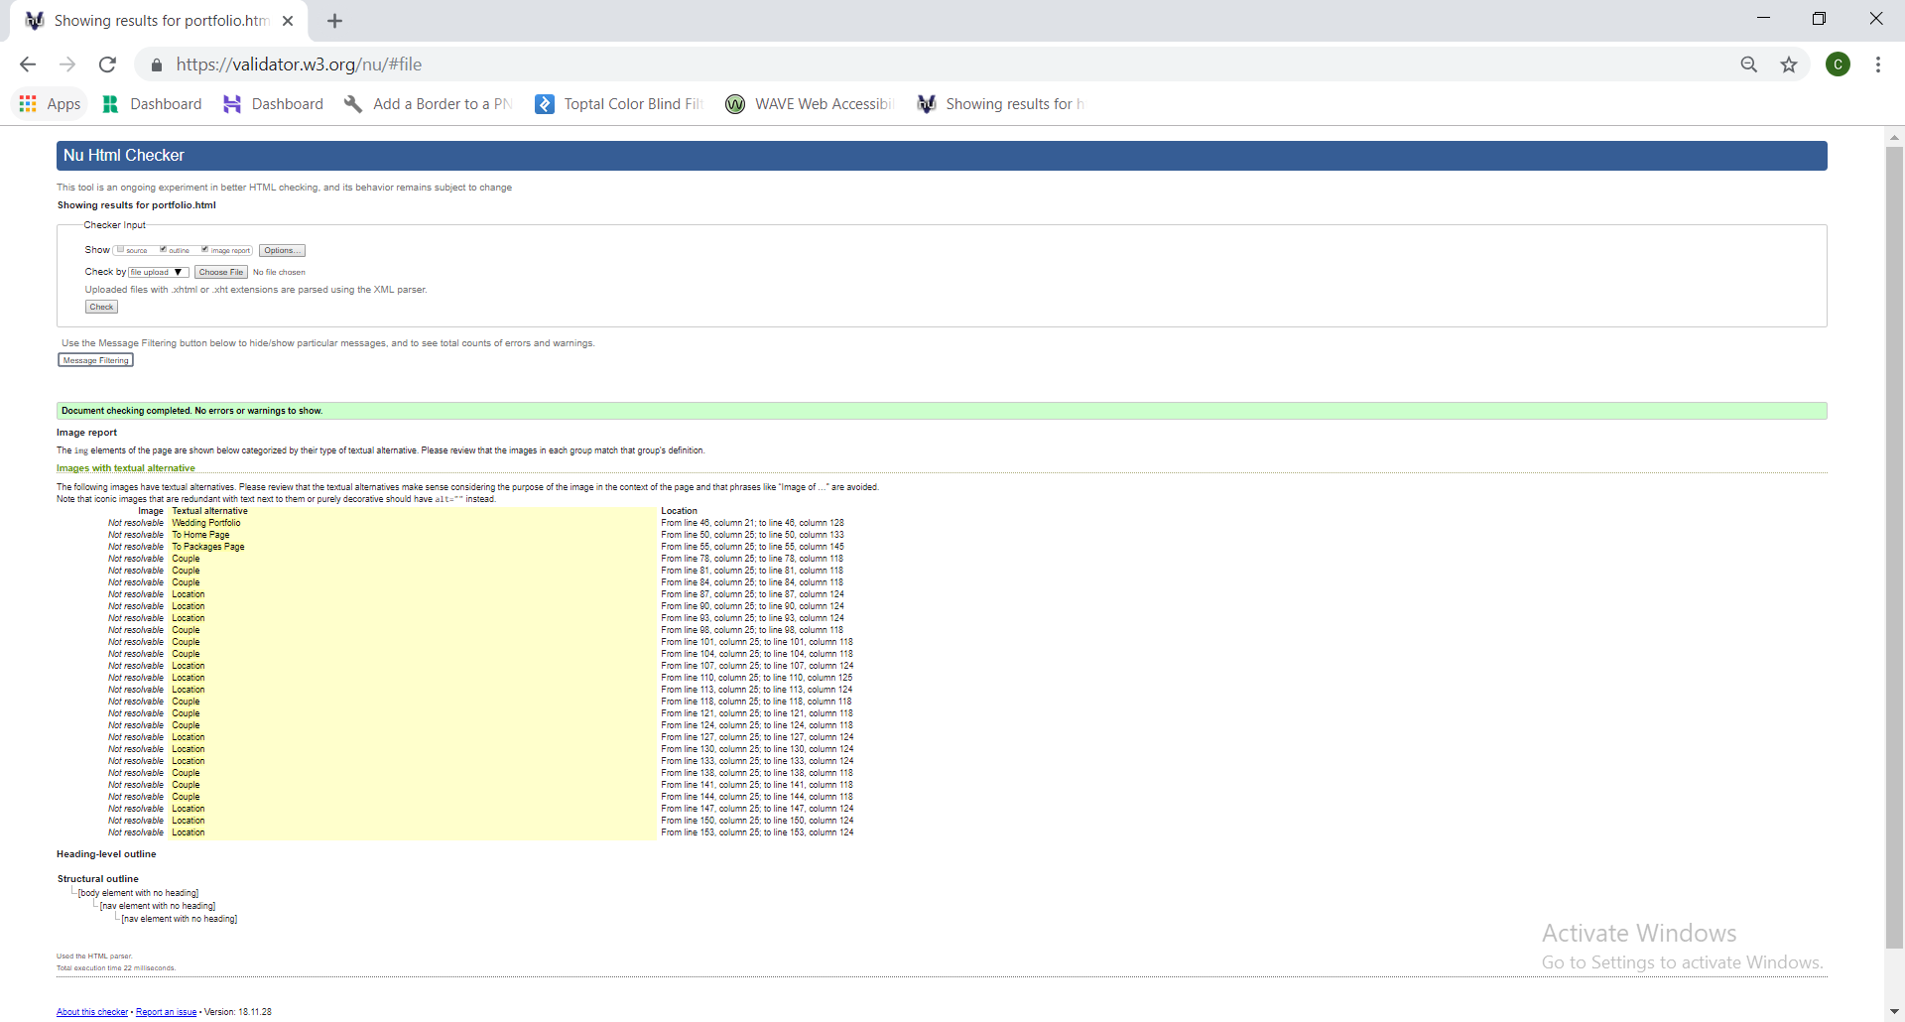

### File – packages.html

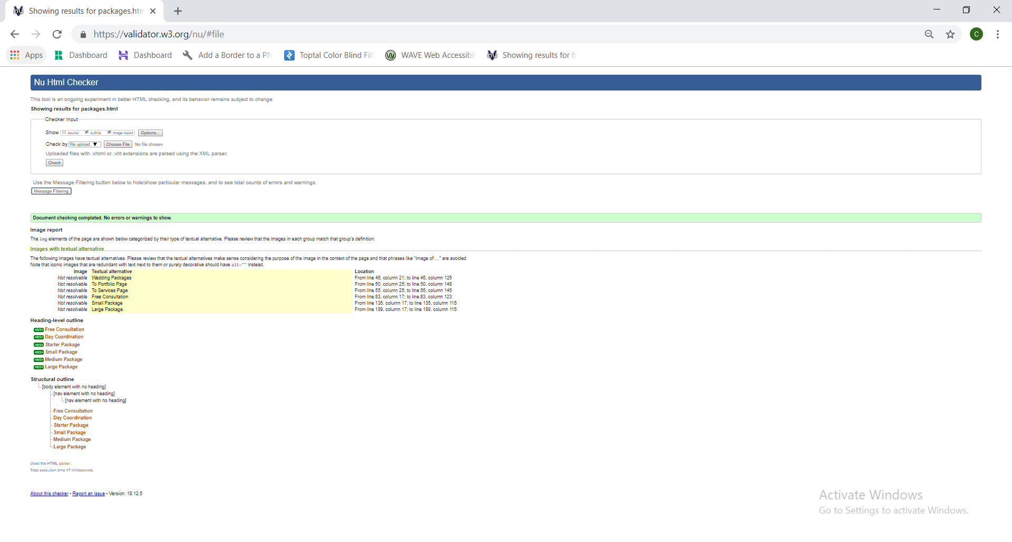

### File – services.html

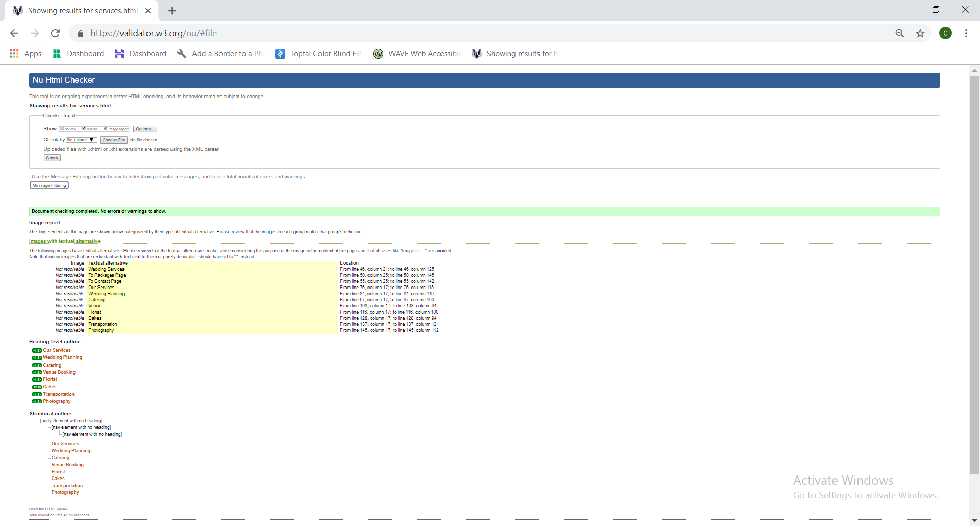

### File – contact.html

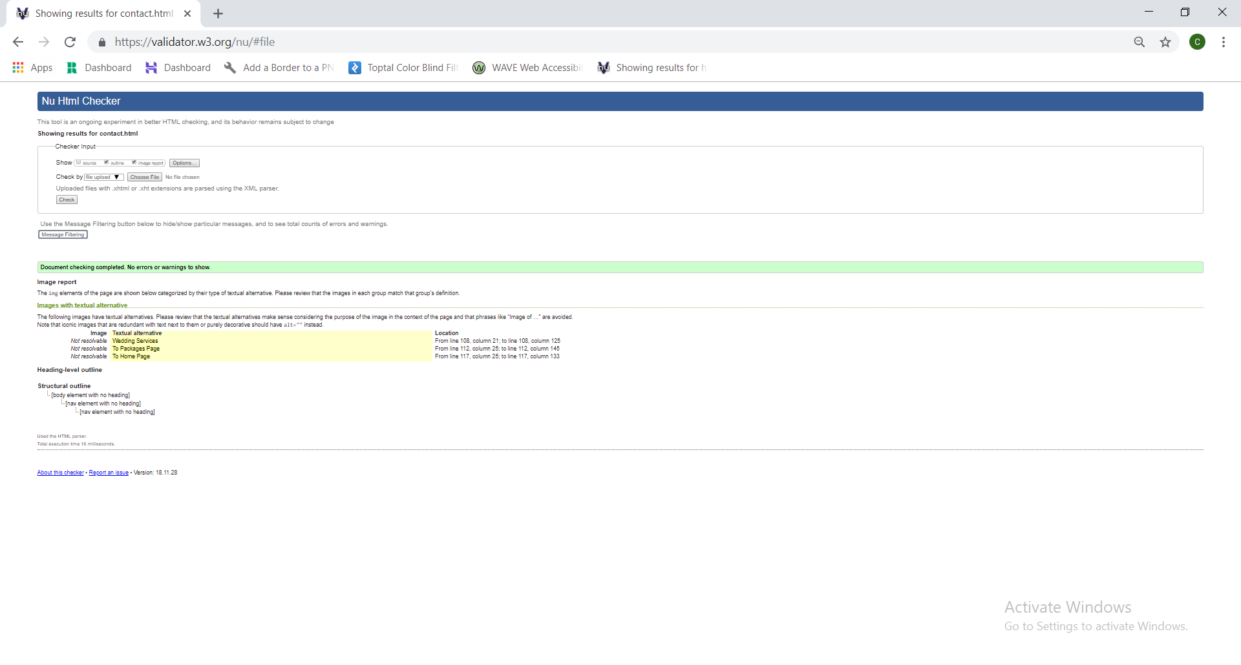

## Web page UI elements and their related code

### Body structure

The body contains a class named main_grid, which is displayed as a grid, where the header, main menu, content and footer are set in one column, and a button with the id back_to_top.

* Html:

…

<body>

<div class="grid">

<header class="header_nav">

…

</header>

<nav class="main_nav">

…

</nav>

<main class="content">

</main>

<footer>

</footer>

</div>

<button id="back_to_top" …> …</button>

</body>

…

* Css:

.grid {

display: grid;

grid-template-columns: 1fr;

grid-template-rows: min-content min-content max-content 1em;

grid-gap: 0px;

grid-template-areas:

"header"

"prim_menu"

"content"

"footer";

}

As seen in the css code snippet above the grid template column is set as one fraction and the template rows are set accordingly to the size of each sub element in the main_grid. The grid_template_areas property auto defines the rows by the name given as a grid-area property in their respective classes.

### Header Element

The header tag is the same as structure in every page. The only differences from page to page is that they have different images set and of course different alt and title tags.

The grid_wrap class encloses and positions the figure elements in a grid.

* Html:

<header class="header_nav">

<div class="grid_wrap">

<figure class="frontPanel marginBorder">

<img class="" src="main image" alt="Home Page" title="Home Page">

</figure>

<figure class="backPanel panel_button">

<a href="contact.html">

<img class="" src="image of previous page" alt="To Contact Page" title="To Contact Page">

</a>

</figure>

<figure class="forwardPanel panel_button">

<a href="portfolio.html">

<img class="" src=" image of next page " alt="To Portfolio Page" title="To Portfolio Page">

</a>

</figure>

</div>

</header>

* Css:

The header_nav class has the grid-area property set to “header” so that it can be binded to the main_grid.

.header_nav {

grid-area: header;

height: min-content;

width: 100%;

}

The grid_wrap class sets the external columns to 1% for simulating margins for the main image. The rest of the width space is divided into 22 fractions so that the back/forward image links can be fine-tuned on the canvas. The rows are set to 9 divisions, each enclosing the minimum content.

.grid_wrap {

display: grid;

grid-template-columns: 1% repeat(22, 1fr) 1%;

grid-template-rows: repeat(9, min-content);

}

The statement below sets a set of rules for all figures in the grid_wrap class. The width rule works here because the columns and rows are set manually with grid-column and grid-row (see below).

.grid_wrap figure {

display: block;

height: fit-content;

width: 100%;

}

The back_panel, front_panel and forward_panel width and height are set with values from 1 to maximum of rows or columns defined in the grid_wrap class. The opacity of the back/forward panels are set to .7 so that the main picture can be viewed in its enteriety.

.backPanel {

opacity: .7;

grid-column: 1/6;

grid-row: 8;

}

.frontPanel {

opacity: 1;

grid-column: 2/24;

grid-row: 1/10;

}

.forwardPanel {

opacity: 0.7;

grid-column: 20/25;

grid-row: 8;

}

On hovering the back/forward panels the image’s opacity is set to full so that it can be better viewed.

.backPanel:hover {

opacity: 1;

}

.forwardPanel:hover {

opacity: 1;

}

The panel_button is a secondary class for the back/forward panels for setting their properties like border shadow etc.

.panel_button {

padding: 0px;

border: 2px solid black;

}

.panel_button:hover {

box-shadow: 0 12px 16px 0 rgba(0, 0, 0, 0.24), 0 17px 50px 0 rgba(0, 0, 0, 0.19);

}

### Main menu element

* Html

The main menu contains a checkbox input represented by the menu_btn_wrap class and has set the onclick action so that it can toggle on/off the main menu when the web page is rendered on mobile devices. The secondary nav is used to house a unordered list with links to the other pages. To show the current page selection, every page has the class selected appended to its own list item.

<nav class="main_nav">

<div class="menu_btn_wrap menu_btn_img_1">

<input id="menu_btn_id" type="checkbox" onclick="showHideMenu()">

</div>

<nav id="menu_id">

<ul>

<li class="selected"><a href="index.html" title="Home">Home</a></li>

<li><a href="portfolio.html" title="Portfolio">Portfolio</a></li>

<li><a href="packages.html" title="Packages">Packages</a></li>

<li><a href="services.html" title="Services">Services</a></li>

<li><a href="contact.html" title="Contact">Contact</a></li>

</ul>

</nav>

</nav>

* Javascript

The function showHideMenu() gets the second nav tag element by id and resets the class to a show or hide state.

function showHideMenu() {

var checkBox = document.getElementById("menu_btn_id");

var menu = document.getElementById("menu_id");

if (checkBox.checked == true) {

menu.className = "menu_show";

} else {

menu.className = "menu_hide";

}

}

* Css

The main_nav class has the grid-area property set to “prim_menu” so that it can be binded to the main_grid.

.main_nav {

grid-area: prim_menu;

background: #6b6c5c;

border-top: 1px solid firebrick;

border-bottom: 1px solid firebrick;

text-align: center;

padding-top: 1px;

padding-bottom: 1px;

margin-top: 1%;

margin-bottom: 1%;

}

The display of the unordered list is set as flex for better elements responsiveness and for justifying content.

.main_nav ul {

display: -ms-flexbox;

/* IE10 */

display: flex;

list-style: none;

font-size: 1em;

font-weight: bold;

font-family: scriptina;

justify-content: space-between;

}

The display of the list item is set as flex for better elements responsiveness and for justifying content.

.main_nav li {

display: -ms-flexbox;

/* IE10 */

display: flex;

background: #6b6c5c;

list-style: none;

width: 100%;

height: 3em;

align-items: center;

justify-content: center;

}

.main_nav a {

list-style: none;

text-decoration: none;

color: white;

}

The background color when hovering the list items is set to firebrick for a better contrast of the menu and the background.

.main_nav li:hover {

background-color: firebrick;

list-style: none;

width: 100%;

height: 3em;

}

When the selected class is set in the menu’s list item it will display a thin firebrick colored bottom/top border.

.selected {

border-bottom: 1px solid firebrick;

border-top: 1px solid firebrick;

}

The input checkbox inside the menu will be hidden by default, it will only show for mobile resolutions.

.menu_btn_wrap {

display: none;

}

### Footer Element

* Html

Nothing special, has small tag for having a smaller font size.

<footer class="footer">

<small>&copy; Copyright 2018, Cosmin Elvis Anita</small>

</footer>

The footer class has the grid-area property set to “footer” so that it can be binded to the main_grid.

* Css

.footer {

grid-area: footer;

background: #78866b;

bottom: 0;

width: 98%;

height: 20px;

right: 0;

margin: 0 auto;

text-align: right;

}

### Go to Top Button

* Html

When clicked it will call the goToTop() javascript function.

<button onclick="goToTop()" id="back_to_top" title="Go To Top">

<p>Go Top</p>

</button>

* Javascript

The window.onscroll listener captures any scroll on the page and it will call the whenScrollHappens function.

window.onscroll = function() {

whenScrollHappens()

};

The function whenScrollHappens() checks if the user has scrolled down 20 pixels, if so it will display the button as a block or else it will hide it.

function whenScrollHappens() {

if (document.body.scrollTop > 20 || document.documentElement.scrollTop > 20) {

document.getElementById("back_to_top").style.display = "block";

} else {

document.getElementById("back_to_top").style.display = "none";

}

}

The function sets the bodies scroll to top property to 0 forcing a scroll to top event.

function goToTop() {

document.body.scrollTop = 0;

document.documentElement.scrollTop = 0;

}

* Css

The back_to_top button has its initial opacity set to 0.7 to not bother the users view. This button is also set in tablet and mobile media query.

#back_to_top {

display: none;

position: fixed;

border: none;

border-radius: 5%;

width: 4em;

height: 5em;

right: 0px;

bottom: 3em;

opacity: 0.7;

text-align: center;

background-color: cadetblue;

}

#back_to_top p {

color:white

}

On hovering the go to top button, the width will be set higher than the initial value for better accessibility and for visual effect.

#back_to_top:hover {

width: 9%;

opacity: 1;}

### Home Page Content

* Html

<main class="content">

<figure class="box_img">

<img src="assets/images/wedding_planner.jpg" alt="Weding Planner Work Space" title="Weding Planner Work Space">

</figure>

<div class="box_title">

<h1>JS Wedding Planners</h1>

</div>

<article class="box_text text_main_1">

<h2>Our Services</h2><br>

<p>Some text</p>

<p>Some text</p>

</article>

<article class="box_text text_main_2">

<h2>About Us</h2><br>

<p>Some text</p>

<p>Some text</p>

</article>

<article class="box_text text_main_3">

<h2>Portfolio</h2><br>

<p>Some text</p>

<p>Some text</p>

</article>

</main>

* Css

The content class has the grid-area property set to “content” so that it can be binded to the main_grid. The display of the content class is set to grid with custom columns/rows for fine tuning, so that the main image, the box texts and the logo intersect.

.content {

grid-area: content;

display: grid;

grid-template-columns: 1em 0.75fr repeat(2, 1em) 1.5fr repeat(2, 1em) 0.75fr 1em;

grid-template-rows: repeat(10, 1em) minmax(min-content, max-content) repeat(10, 1em) minmax(min-content, max-content);

background: #78866b;

grid-gap: 0px;

margin: 1%;

width: 98%;

}

Normal_content class is set as a secondary class for the content which is not set as a grid.

.normal_content {

background: #78866b;

grid-gap: 0px;

margin: 1%;

width: 98%;

height: fit-content;

}

.box_title {

grid-column: 2/5;

grid-row: 2/7;

}

.box_title h1 {

text-align: center;

font-family: scriptina;

font-size: 2.25em;

font-weight: bolder;

line-height: 1.3em;

color: black;

text-shadow: 0.5px 0.5px 0.5px white;

}

.box_img {

grid-column: 2/9;

grid-row: 1/18;

}

.box_img figure {

width: fit-content;

height: fit-content;

}

.text_main_1 {

grid-column: 2/4;

grid-row: 14/23;

}

.text_main_2 {

grid-column: 5;

grid-row: 17/23;

}

.text_main_3 {

grid-column: 7/9;

grid-row: 12/23;

}

.box_text h1,h2,

h3,

h4,

h5,

h6,

h7,

h8,

h9 {

text-align: center;

line-height: 1em;

font-family: scriptina;

font-weight: bold;

padding: 0.5em;

text-shadow: 0.5px 0.5px 0.5px white;

}

.box_text p {

text-align: left;

text-indent: 1em;

width: fit-content;

height: fit-content;

}

.box_text p::first-letter {

font-family: scriptina;

font-weight: bold;

font-size: 1.1em;

}

### Portfolio Page Content

* Html

The main tag is set with the normal_content because it doesn’t use the grid display. Instead it uses a neat trick where the gallery class is divided into columns with the same width, and all the images in a column have the total height equal to the other height sums.

<main class="normal_content">

<div class="gallery">

<div class="gallery_column">

<figure>

<img src="some image" alt="Couple" title="Couple">

</figure>

...

<figure>

<img src=="some image" alt="Couple" title="Couple">

</figure>

</div>

</div>

</main>

* Css

The display of the gallery class is set to flex for a better web page responsitivity.

.gallery {

display: -ms-flexbox;

/* IE10 */

display: flex;

-ms-flex-wrap: wrap;

/* IE10 */

flex-wrap: wrap;

align-items: center;

justify-content: center;

width: 100%;

}

The gallery_column is set to flex 25% with a 25% max width on the desktop resolutions.

.gallery_column {

-ms-flex: 25%;

/* IE10 */

flex: 25%;

max-width: 25%;

padding: 0 0.5em;

}

.gallery img {

margin-top: 1em;

margin-bottom: 1em;

vertical-align: middle;

width: 100%;

}

### Packages Page Content

* Html

The main tag has the packages_grid class set as primary grid and the content grid class set as a secondary class for inheriting all the other properties from it. The grid is auto completed by the order of the elements in it.

<main class="packages_grid content">

<article class="box_text text_1">

<h1>Free Consultation</h1><br>

<p>Some Text</p>

</article>

<figure class="img_2">

<img src="some image" alt="Free Consultation" title="Free Consultation">

</figure>

<article class="box_text text_2">

<h1>Day Coordination</h1><br>

<p>Some Text</p>

</article>

<article class="box_text text_3">

<h1>Starter Package</h1><br>

<p>Some Text</p>

</article>

<figure class="img_1">

<img src="some image" alt="Small Package" title="Small Package">

</figure>

<article class="box_text text_4">

<h1>Small Package</h1><br>

<p>Some Text</p>

</article>

<article class="box_text text_5">

<h1>Medium Package</h1><br>

<p>Some Text</p></article>

<figure class="img_3">

<img src="some image" alt="Large Package" title="Large Package">

</figure>

<article class="box_text text_6">

<h1>Large Package</h1><br>

<p>Some Text</p>

</article>

</main>

* Css

On the desktop resolutions the package grid is consisted of two equal columns and 5 rows with min-content option.

.packages_grid {

display: grid;

grid-template-columns: repeat(2, 1fr);

grid-template-rows: repeat(5, min-content);

grid-gap: 1em;

}

.packages_grid article {

display: flex;

justify-content: center;

/* align horizontal */

align-items: center;

/* align vertical */

padding: 0.3em;

}

### Services Page Content

* Html

The main tag contains the normal_content to inherit its properties and the services_container grid class. The grid is auto populated in the order of the elements in it.

<main class="normal_content services_container">

<figure>

<img src="assets/images/services/our_services_500_500.jpg" alt="Our Services" title="Our Services">

</figure>

<article>

<h1>Our Services</h1><br>

<p>Some Text<p/>

</article>

<figure>

<img src="assets/images/services/planning_500_500.jpg" alt="Wedding Planning" title="Wedding Planning">

</figure>

<article>

<h1>Wedding Planning</h1><br>

<p>Some Text<p/>

</article>

<figure>

<img src="assets/images/services/catering_500_500.jpg" alt="Catering" title="Catering">

</figure>

<article class="">

<h1>Catering</h1><br>

<p>Some Text<p/></article>

<figure>

<img src="assets/images/services/venue_500_500.jpg" alt="Venue" title="Venue">

</figure>

<article class="">

<h1>Venue Booking</h1><br>

<p>Some Text<p/>

</article>

<figure>

<img src="assets/images/services/florist_500_500.jpg" alt="Florist" title="Florist">

</figure>

<article class="">

<h1>Florist</h1><br>

<p>Some Text<p/>

</article>

<figure>

<img src="assets/images/services/cakes_500_500.jpg" alt="Cakes" title="Cakes">

</figure>

<article class="">

<h1>Cakes</h1><br>

<p>Some Text<p/>

</article>

<figure>

<img src="assets/images/services/transportation_500_500.jpg" alt="Transportation" title="Transportation">

</figure>

<article class="">

<h1>Transportation</h1><br>

<p>Some Text<p/>

</article>

<figure>

<img src="assets/images/services/photography_500_500.jpg" alt="Photography" title="Photography">

</figure>

<article class="">

<h1>Photography</h1><br>

<p>Some Text<p/>

</article>

</main>

* Css

On the desktop resolutions the services grid is consisted of two equal columns and 8 rows with min-content option.

.services_container {

display: grid;

grid-template-columns: repeat(2, 1fr);

grid-template-rows: repeat(8, min-content);

}

The articles in the services_container are set to flex for a responsive experience.

.services_container article {

display: flex;

align-items: center;

justify-content: center;

padding: 1em;

}

.services_container figure {

display: flex;

align-items: center;

justify-content: center;

}

The images in the services_container are rounded with the border radius property set to 50%.

.services_container img {

border-radius: 50%;

padding: 1em;

}

### Contact Page Content

* Html

The main tag has the normal_content class set. It is divided into a fieldset, a form and a div which contains a video and a Bing map.

<main class="normal_content">

<div class="contact_details">

<div class="form">

<fieldset>Explained Underneath</fieldset>

<form id="frm_id" …> Explained Underneath </form>

</div>

</div>

<div class="location_details">

<video src="/assets/video/dest_video_640_480.mp4" controls>

Unfortunately your browser does not support HTML5 video.

</video>

<div class="map" id="bing_map">

</div>

</div>

</main>

The fieldset tag contains the companies contact details structured as an unordered list. The list contains company address, working hours table, email and phone details.

<fieldset>

<legend>Our Contact Details</legend>

<p>We look forward to connecting with you! Please contact us for a complimentary consultation and portfolio presentation. Please complete the form below, or contact us at:</p>

<ul>

<li>Address:

999999 Uk's Rd, Street 111

London, NN 92122<br><br><b>Opening Hours:</b></li>

<li>

<table>

<tr>

<th>Day</th>

<th>Interval</th>

</tr>

<tr>

<td>Monday</td>

<td>9am - 5pm</td>

</tr>

<tr>

<td>Tuesday</td>

<td>9am - 5pm</td>

</tr>

<tr>

<td>Wednesday</td>

<td>9am - 5pm</td>

</tr>

<tr>

<td>Thursday</td>

<td>9am - 5pm</td>

</tr>

<tr>

<td>Friday</td>

<td>9am - 5pm</td>

</tr>

<tr>

<td>Saturday</td>

<td>9am - 5pm</td>

</tr>

<tr>

<th>Sunday</th>

<th>Closed</th>

</tr>

</table>

<li>

<li>Email: info@jsweddingplanners.com</li>

<li>Phone: 99999-99999-99999</li>

</ul>

</fieldset>

The form sends the data with a post request to a dummy rest api server as a json object. The url address has been set just for proof of concept and to show that the form data is sent. The form contains a fieldset tag for visual symmetry with the companies contact details fieldset. The form contains labels, several inputs, a textarea, an option selector and of course a submit button. They will all be explained in detail underneath.

<form id="frm_id" method="POST" action="https://jsonplaceholder.typicode.com/posts">

<fieldset>

<legend>Contact Us</legend>

…

</fieldset>

</form>

The firstName input has the maximum length set to 30 characters and it is required. It has a regular expression set as a pattern which doesn’t take numeric values and must have at least one letter inserted. The title is set to a generic error message and the placeholder is set to * to show that it is required.

<input id="firstName" type="text" name="fname" maxlength="30" required pattern="[a-zA-z]{1,}" title="Please enter your first name!" placeholder="*">

The lastName input has the maximum length set to 30 characters and it is required. It has a regular expression set as a pattern which doesn’t take numeric values and must have at least one letter inserted. The title is set to a generic error message and the placeholder is set to * to show that it is required.

<input id="lastName" type="text" name="lname" maxlength="30" required pattern="[a-zA-z]{1,}" title="Please enter your last name!" placeholder="*">

The gender selector has three options, and has a default value set.

<select id="gender" name="genderName">

<option value="Female" selected>Female</option>

<option value="Male">Male</option>

<option value="Other">Other</option>

</select>

The email input has the maximum length set to 30 characters and it is required. It has a regular expression set as a pattern which only takes mail formats. The title is set to a generic error message and the placeholder is set to * to show that it is required.

<input id="email" type="text" name="email" maxlength="30" required pattern="[a-z0-9._%+-]+@[a-z0-9.-]+\.[a-z]{2,4}$" title="Please enter a valid email address!" placeholder="*">

The telephone input is set as required with maximum length set to 20 and has a regular expression set as a pattern which only takes numeric with the length between 8 and 20. The title is set to a generic error message and the placeholder is set to * to show that it is required.

<input id="tel" type="text" name="telNo" max-length="20" required pattern="[0-9]{8,20}" title="Please enter a valid phone number!" placeholder="*">

The textarea tag is set as required, accepts a maximum length of 500 characters and has 20 rows. The placeholder is set to a generic message and has no title because of this.

<textarea id="msg" name="message" rows="20" maxlength="500" required placeholder="Type Your Message Here! *">

In a form tag the submit button automatically binds with its request attributes, if they exist, sending the data when being clicked.

<button class="submit_button">Submit</button>

The video tag is set up with controls and an error message in case the user’s browser doesn’t support HTML5.

<video src="/assets/video/dest_video_640_480.mp4" controls>

Unfortunately your browser does not support HTML5 video.

</video>

* Javascript

The function is set to start when the body loads. As presented in the code the data is sent through a GET request with the variables set as attributes in the url address.

function GetMap() {

// Define the address on which to centre the map

var addressLine = ""; // Street Address

var locality = "London"; // City or town name

var adminDistrict = ""; // County

var country = "UK"; // Country, obviously

var postalCode = "EC1R4TF" //Postcode

// Construct a request to the REST geocode service

var geocodeRequest = "http://dev.virtualearth.net/REST/v1/Locations" +

"?countryRegion=" + country +

"&addressLine=" + addressLine +

"&locality=" + locality +

"&adminDistrict=" + adminDistrict +

"&postalCode=" + postalCode +

"&key=" + credentials +

"&jsonp=GeocodeCallback"; // This function will be called after the geocode service returns its results

// Call the service

CallRestService(geocodeRequest);

}

The GeocodeCallback() function receives the response from the GET request, checks the data and if it is valid creates a map in the id of the designated div container and sets a push pin on the companies address.

function GeocodeCallback(result) {

// Check that we have a valid response

if (result && result.resourceSets && result.resourceSets.length > 0 && result.resourceSets[0].resources && result.resourceSets[0].resources.length > 0) {

// Create a Location based on the geocoded coordinates

var coords = result.resourceSets[0].resources[0].point.coordinates;

centerPoint = new Microsoft.Maps.Location(coords[0], coords[1]);

// Create a map centred on the location

map = new Microsoft.Maps.Map(document.getElementById("bing_map"), {

credentials: credentials,

center: centerPoint,

mapTypeId: Microsoft.Maps.MapTypeId.aerial,

zoom: 18

});

// Add a pushpin as well

var pushpin = new Microsoft.Maps.Pushpin(map.getCenter());

map.entities.push(pushpin);

}

}

This is a generic function to call a REST service and insert the JSON results into the head of the document. After this call the GeocodeCallback() function will activate.

function CallRestService(request) {

var script = document.createElement("script");

script.setAttribute("type", "text/javascript");

script.setAttribute("src", request);

var dochead = document.getElementsByTagName("head").item(0);

dochead.appendChild(script);

}

* Css

The display of the contact_details class is set to flex for responsiveness.

.contact_details {

display: flex;

align-items: center;

justify-content: center;

}

The display of the form class is set to table to better divide the form tags elements like labels, inputs, textarea, selector etc.

.form {

display: table;

margin: 1em;

width: 50%;

vertical-align: center;

}

.form td {

text-align: left;

}

.form th {

text-align: left;

}

The paragraph from the form class is set as table-row because the form tags elements are wrapped in p tags to divide them in rows.

.form p {

display: table-row;

width: 100%;

text-align: center;

}

.form legend,

li {

padding: 1em;

}

.form legend{

font-weight: bold;

color: black;

text-shadow: 0.5px 0.5px 0.5px white;

}

This property disables the seconds list item style type because it contains the table with the companies working hours.

.form li:nth-child(2) {

list-style-type: none;

}

The labels in the form are set as table cells for division in the form tag.

.form label {

display: table-cell;

text-align: left;

width: 10%;

padding:5px;

}

This property sets the border to 1px with red color for the inputs when the text is invalid or if the required ones have no characters.

.form input:required:invalid,

input:focus:invalid {

border: 1px solid red;

}

This elements are as table cells for division in the form tag.

.form select,

input,

textarea {

display: table-cell;

margin: 1em;

text-align: left;

width: 90%;

}

.submit_button {

background-color: firebrick;

border: none;

color: black;

padding-left: 3em;

padding-right: 3em;

padding-top: 2em;

padding-bottom: 2em;

margin: 1em;

text-align: center;

text-decoration: none;

font-size: 12px;

font-weight: bold;

cursor: pointer;

color:white;

}

.contact_details ul,

li {

list-style-type: circle;

margin-left: 10px;

}

The location_details class is displayed as a grid, and on the desktop, screens will have two equal columns and a single row set to min-content. This will ensure responsiveness on the other devices.

.location_details {

display: grid;

grid-template-columns: 1fr 1fr;

grid-template-rows: min-content;

grid-template-areas:

"video map";

}

.location_details video {

grid-area: video;

border: 1px solid black;

width: 99%;

margin-top: 1%;

margin-bottom: 1%;

margin-left: 1%;

margin-right: 0px;

}

.map {

grid-area: map;

border: 1px solid black;

width: 98%;

margin-top: 1%;

margin-bottom: 1%;

margin-left: 1%;

margin-right: 1%;

}

### Mobile media query

The mobile media query applies for resolutions from 0px to 599px.

@media screen and (max-width: 599px) and (min-width: 0px) {

The back/forward panels are enlarged for better accessibility.

.backPanel {

opacity: 1;

grid-column: 1/10;

grid-row: 8;

}

.forwardPanel {

opacity: 1;

grid-column: 16/25;

grid-row: 8;

}

The main_nav is in hidden state when the page starts.

.main_nav ul {

display: none;

}

The menu button for mobile devices is set as a block and is forced to float on the left.

.menu_btn_wrap {

display: block;

float: left;

bottom: 0;

margin: 0;

width: 30px;

height: 3em;

}

The menu_btn_X classes are used for changing the menu button state. The button has 5 horizontal lines which represents a mini menu showing the selection state of the page by highlighting one line according to the page loaded.

.menu_btn_img_1 {

background-image: url('/assets/images/buttons/menu_btn_1_30_30.png');

background-size: 100% 100%;

}

.menu_btn_img_2 {

background-image: url('/assets/images/buttons/menu_btn_2_30_30.png');

background-size: 100% 100%;

}

.menu_btn_img_3 {

background-image: url('/assets/images/buttons/menu_btn_4_30_30.png');

background-size: 100% 100%;

}

.menu_btn_img_4 {

background-image: url('/assets/images/buttons/menu_btn_3_30_30.png');

background-size: 100% 100%;

}

.menu_btn_img_5 {

background-image: url('/assets/images/buttons/menu_btn_5_30_30.png');

background-size: 100% 100%;

}

The menu button is hidden using the opacity property.

#menu_btn_id {

opacity: 0;

bottom: 0;

margin: 0;

width: 100%;

height: 100%;

}

The class is used to reset the main menu display state to block using javascript scripting when the menu button is clicked.

.menu_show {

display: block;

}

.menu_show ul {

display: flow-root;

}

The class is used to reset the main menu display state to none using javascript scripting when the menu button is clicked.

.menu_hide {

display: none;

}

The home pages content is resized according to the device.

.content {

grid-template-columns: 1em 1fr repeat(2, 1em) 1em repeat(2, 1em) 1fr 1em;

grid-template-rows: minmax(min-content, max-content) minmax(min-content, 0.5fr) minmax(min-content, max-content);

}

.box_title {

display: none;

}

.text_main_2 {

grid-column: 2/9;

grid-row: 1;

}

.box_img {

grid-column: 2/9;

grid-row: 2;

}

.box_img figure {

width: fit-content;

height: fit-content;

}

.text_main_1 {

grid-column: 2/5;

grid-row: 3;

}

.text_main_3 {

grid-column: 6/9;

grid-row: 3;

}

The portfolio page content will flex in one column.

.gallery_column {

-ms-flex: 100%;

flex: 100%;

max-width: 100%;

}

The services page content will be displayed as one column.

.services_container {

display: grid;

grid-template-columns: 1fr;

grid-template-rows: repeat(16, min-content);

}

.services_container img {

width: 60%;

}

.services_container h1 {

font-size: 1em;

font

}

The packages page content will be displayed as one column.

.packages_grid {

display: grid;

grid-template-columns: 1fr;

grid-template-rows: repeat(9, min-content);

grid-gap: 1em;

}

.form {

width: min-content;

}

The contact pages video and map will be displayed in one column.

.location_details {

grid-template-columns: 1fr;

grid-template-rows: 1fr 1fr;

grid-template-areas:

"video"

"map";

}

.location_details video {

width:98%;

margin-top: 0px;

margin-left: 1%;

margin-bottom: 1%;

margin-right: 1%;

}

.map {

width: 98%;

margin-top: 0px;

margin-left: 1%;

margin-bottom: 1%;

margin-right: 1%;

}

The back to top button is resized according to the size of the device.

#back_to_top {

width: 2em;

height: 3em;

bottom: 2em;

}

### Tablet media query

The tablet media query applies for resolutions from 600px to 800px.

@media screen and (max-width: 800px) and (min-width: 600px) {

The back/forward panels are enlarged for better accessibility.

.backPanel {

opacity: 1;

grid-column: 1/8;

grid-row: 8;

}

.forwardPanel {

opacity: 1;

grid-column: 18/25;

grid-row: 8;

}

The home pages content is resized according to the device.

.box_title h1 {

text-align: center;

font-family: scriptina;

font-size: 1.5em;

font-weight: bolder;

line-height: 1.3em;

}

.gallery_column {

-ms-flex: 50%;

flex: 50%;

max-width: 50%;

}

The services page content will be displayed as one column.

.services_container {

display: grid;

grid-template-columns: 1fr;

grid-template-rows: repeat(16, min-content);

}

.services_container img {

width: 50%;

}

.services_container h1 {

font-size: 1.5em;

}

The packages page content will be displayed as one column.

.packages_grid {

display: grid;

grid-template-columns: 1fr;

grid-template-rows: repeat(9, min-content);}

The contact pages video and map will be displayed in one column.

.location_details {

grid-template-columns: 1fr;

grid-template-rows: 1fr 1fr;

grid-template-areas:

"video"

"map";

}

.location_details video {

width:98%;

margin-top: 0px;

margin-left: 1%;

margin-bottom: 1%;

margin-right: 1%;

}

.map {

width: 98%;

margin-top: 0px;

margin-left: 1%;

margin-bottom: 1%;

margin-right: 1%;

}

The back to top button is resized according to the size of the device.

#back_to_top {

width: 3em;

height: 4em;

bottom: 2.5em;

}

}

### Global Css file

This is a css used for global styles like the “*” or setting the body or all the paragraphs. What is good to mention is that beside the serif font family I’ve set a local font file for a more of a handwritten style approach for the headers and the main menu.

@font-face {

font-family: scriptina;

src: url(../fonts/SCRIPTIN.ttf);

}

# Testing and validation:

## Browser compatibility and Device responsiveness

The test was done on three different resolutions and on three different browsers. The browsers used for testing compatibility are Chrome, Opera and Firefox.

Because of the extended use of the grids feature, as shown in the Figure 33 captured from the site <https://caniuse.com>, the browser compatibility for grids is about 88%. Therefore, even if I tested the site on IE browsers the feature still doesn’t work properly on them

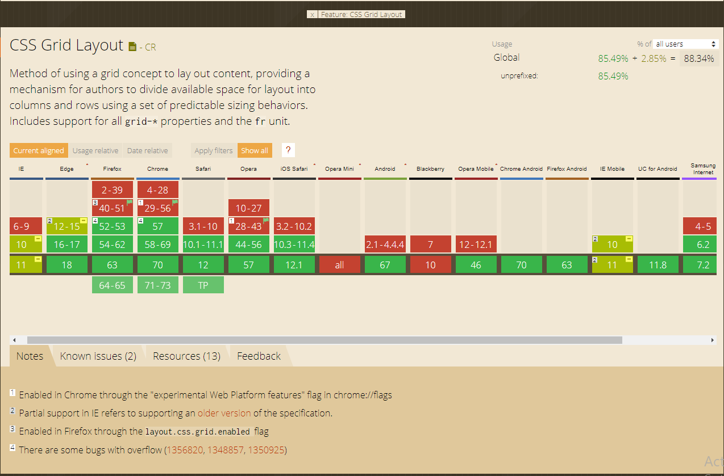

Figure 33

### Chrome Compatibility and Responsiveness Test

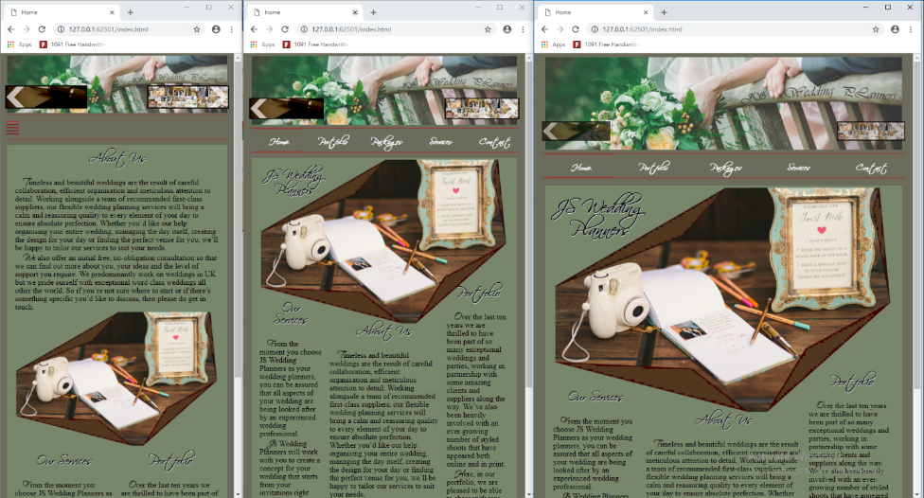

Figure 34

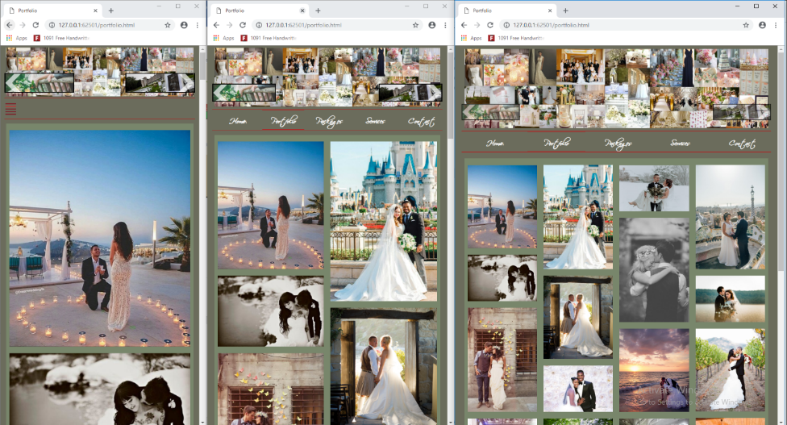

Figure 35

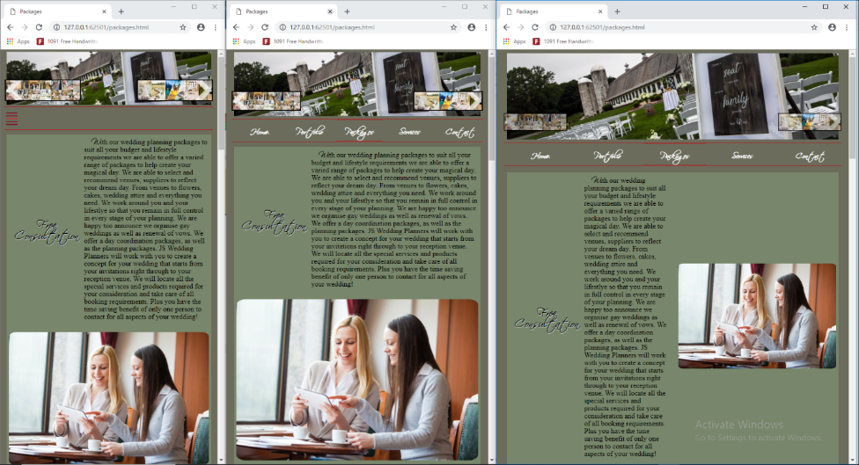

Figure 36

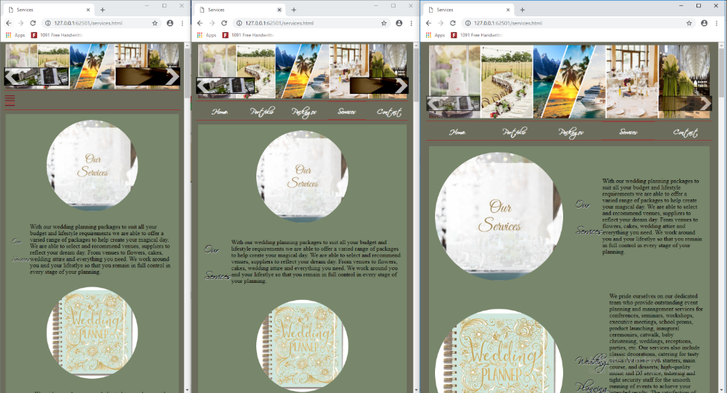

Figure 37

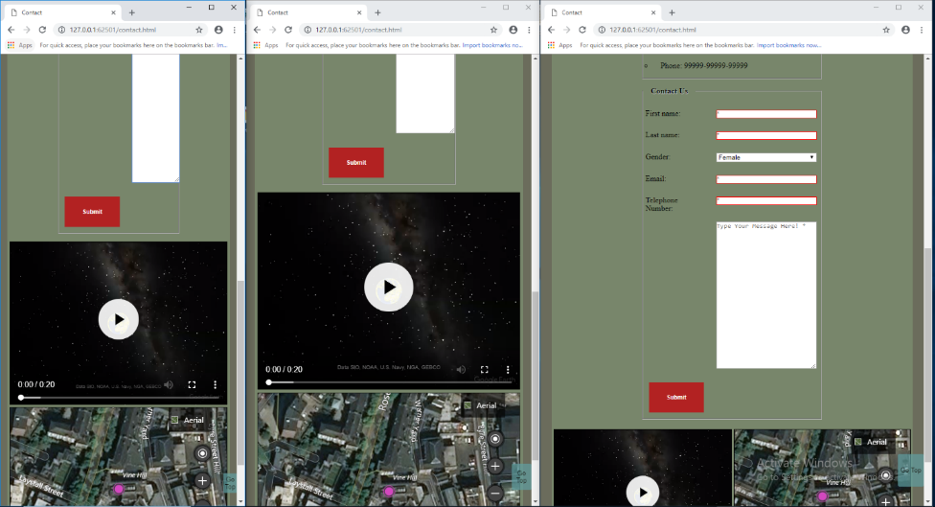

Figure 38

### Opera Compatibility and Responsiveness Test

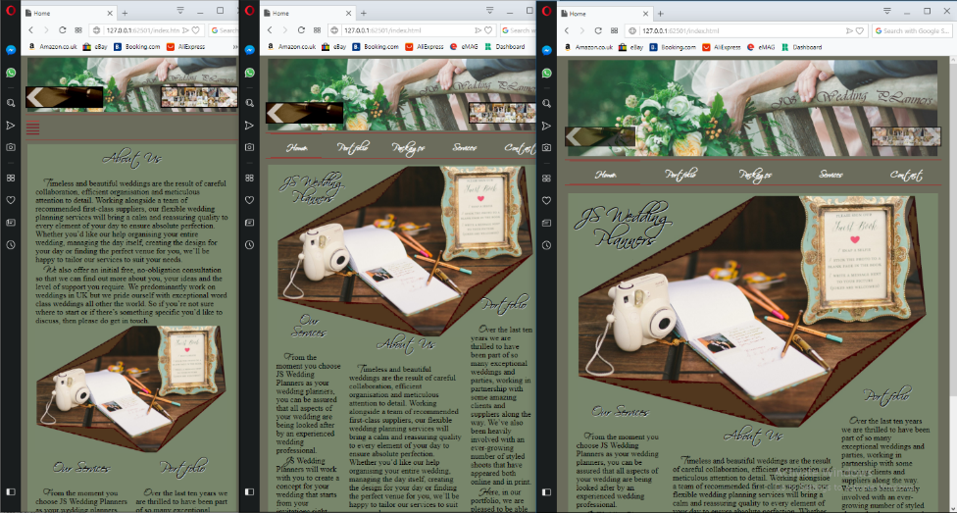

Figure 39

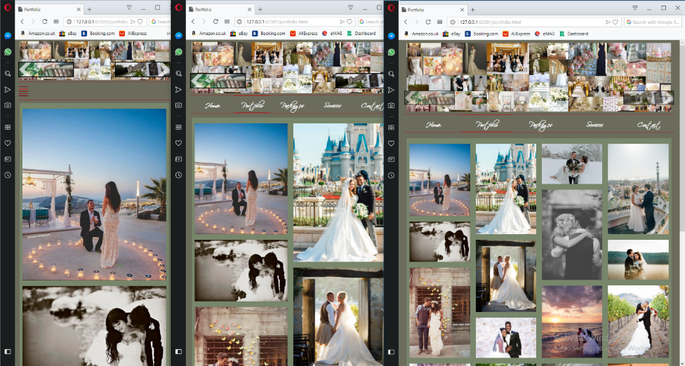

Figure 40

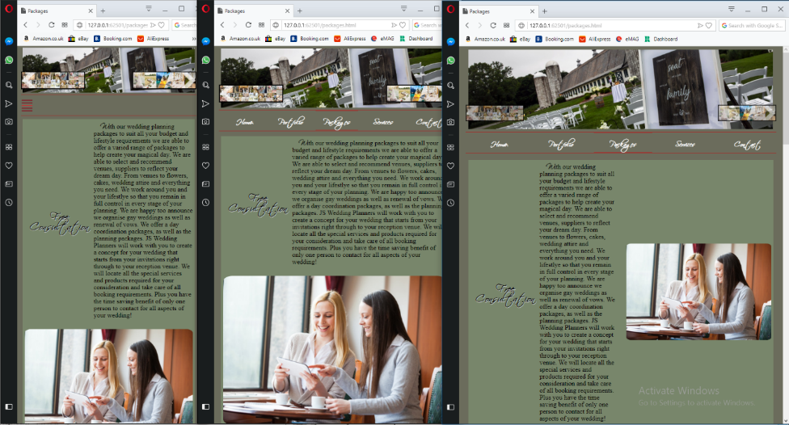

Figure 41

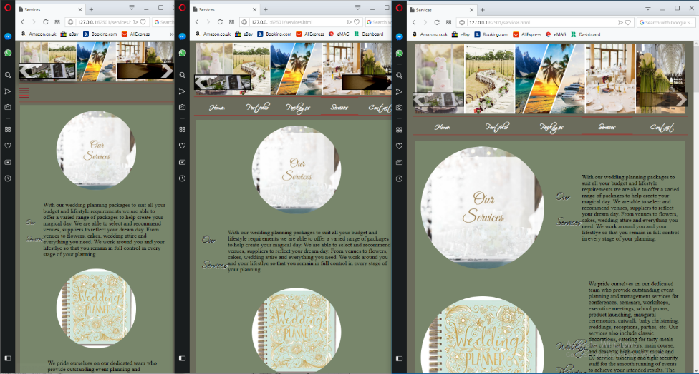

Figure 42

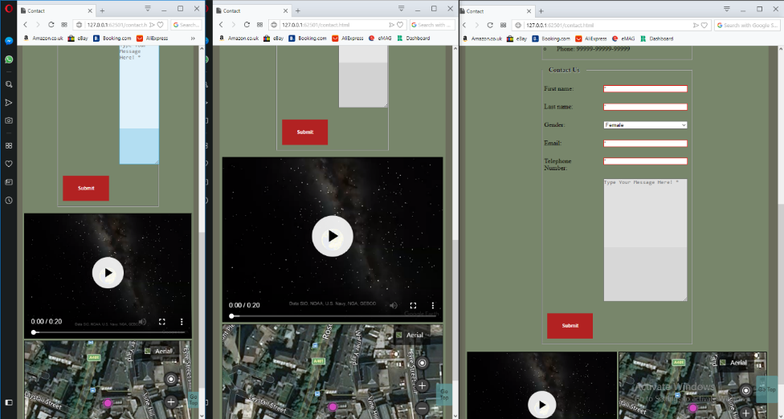

Figure 43

### Firefox Compatibility and Responsiveness Test

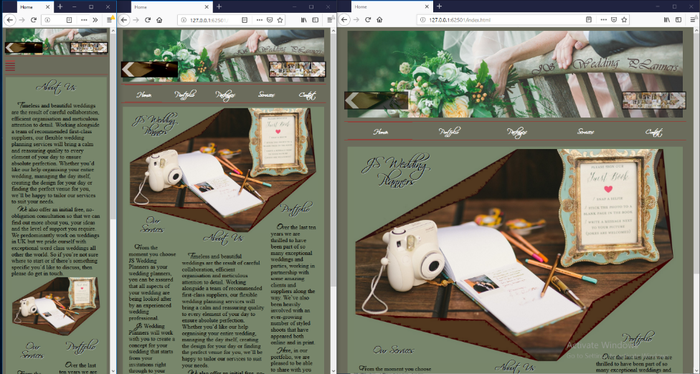

Figure 44

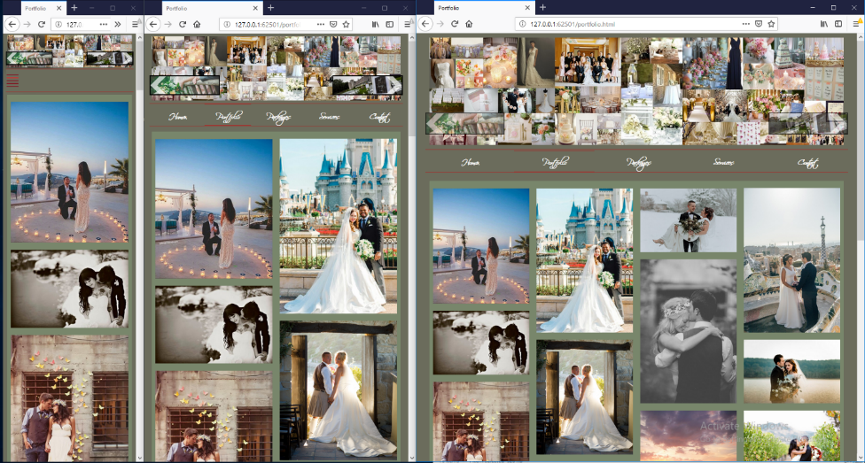

Figure 45

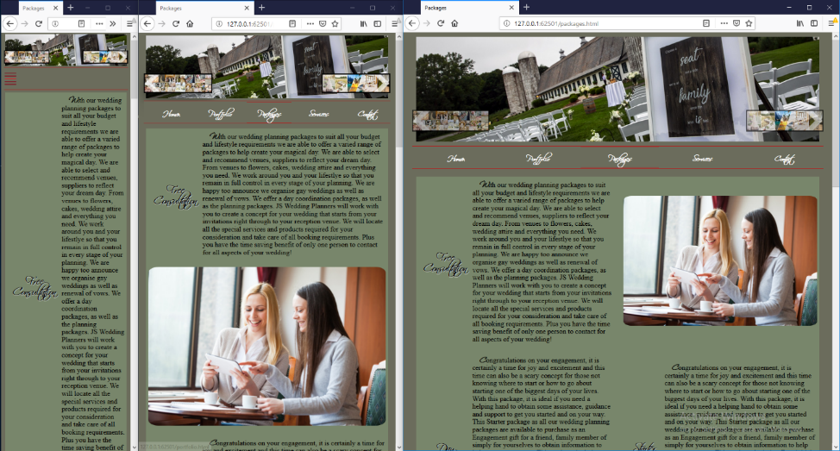

Figure 46

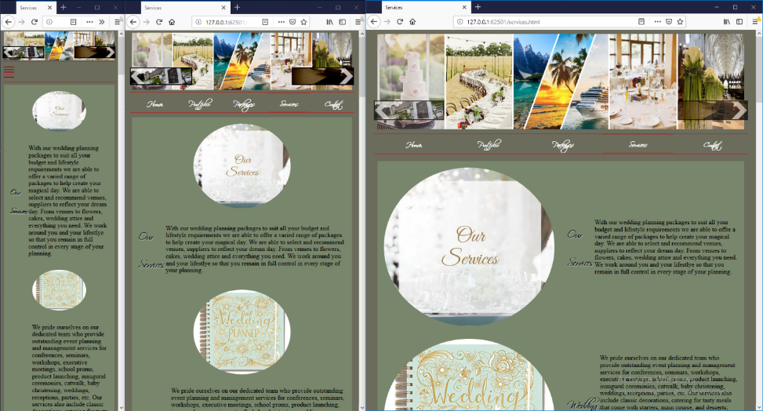

Figure 47

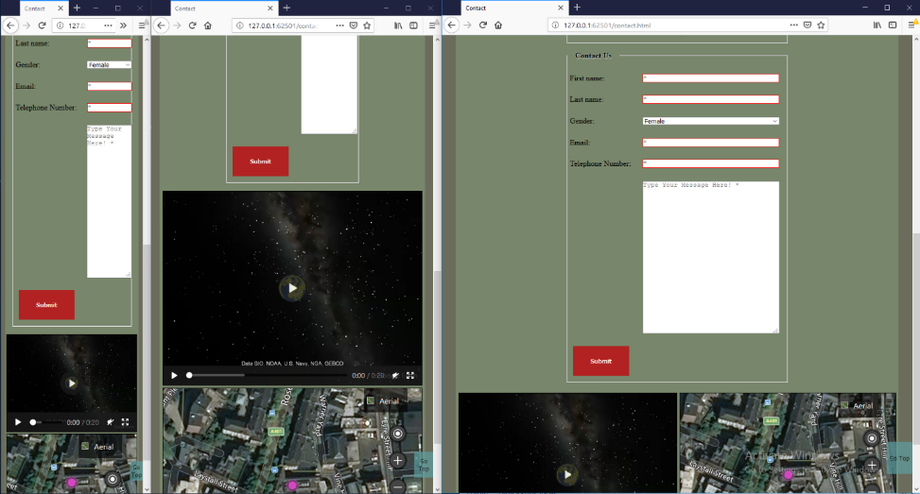

Figure 48

## Test Table

|  |  |  |  |  |
| --- | --- | --- | --- | --- |
| **Web Page** | **Element/Feature** | **Action/Event** | **Foreseen Result** | **Result(Pass/Fail)** |
| Home | Mobile Page Menu Button | Check if the Mobile Page Menu Button is visible on tablet and desktop | Mobile Page Menu Button is hidden | Pass |
|  | Mobile Page Menu Button | Check if the Mobile Page Menu Button is visible on mobile | Mobile Page Menu Button is visible | Pass |
|  | Mobile Page Menu Button | Check if the Mobile Page Menu Button is toggling the mobile horizontal menu from hidden to visible and vice versa | Mobile Page Menu Button toggles the horizontal menu from hidden to visible and vice versa | Pass |
|  | Content Text | Check if the text from the content overflows the content image | The content image has not text over it | Pass |
|  | Context Image | Check if the context image is overflows over the text | The content image doesn’t overflow the text | Pass |
|  | Left Button Panel | Check if the button is pressed loads the contact page | Loads contact page | Pass |
|  | Right Button Panel | Check if the button is pressed loads the portfolio page | Loads portfolio page | Pass |
|  | Menu Items | Check if the menu item loads its according page | Every menu item loads its according page | Pass |
|  | Menu Items + Button Panels +  Go To Top Button | Check if all the buttons have hover effect | All buttons on the page have hover effect | Pass |
|  | Go To Top Button | Check if the Go To Top Button moves the page up | Go To Top Button moves the page up | Pass |
| Portfolio | Mobile Page Menu Button | Check if the Mobile Page Menu Button is visible on tablet and desktop | Mobile Page Menu Button is hidden | Pass |
|  | Mobile Page Menu Button | Check if the Mobile Page Menu Button is visible on mobile | Mobile Page Menu Button is visible | Pass |
|  | Mobile Page Menu Button | Check if the Mobile Page Menu Button is toggling the mobile horizontal menu from hidden to visible and vice versa | Mobile Page Menu Button toggles the horizontal menu from hidden to visible and vice versa | Pass |
|  | Content Gallery | Check if the Content Gallery is responsive | The Content Gallery resizes from 4 columns on desktop to 2 columns on tablet and one column on mobile | Pass |
|  | Content Gallery | Check if the Content Gallery has the images symmetric on any device | The content gallery has the columns equal in height and width on any resolution | Pass |
|  | Left Button Panel | Check if the button is pressed loads the contact page | Loads contact page | Pass |
|  | Right Button Panel | Check if the button is pressed loads the portfolio page | Loads portfolio page | Pass |
|  | Menu Items | Check if the menu item loads its according page | Every menu item loads its according page | Pass |
|  | Menu Items + Button Panels +  Go To Top Button | Check if all the buttons have hover effect | All buttons on the page have hover effect | Pass |
|  | Go To Top Button | Check if the Go To Top Button moves the page up | Go To Top Button moves the page up | Pass |
| Package | Mobile Page Menu Button | Check if the Mobile Page Menu Button is visible on tablet and desktop | Mobile Page Menu Button is hidden | Pass |
|  | Mobile Page Menu Button | Check if the Mobile Page Menu Button is visible on mobile | Mobile Page Menu Button is visible | Pass |
|  | Mobile Page Menu Button | Check if the Mobile Page Menu Button is toggling the mobile horizontal menu from hidden to visible and vice versa | Mobile Page Menu Button toggles the horizontal menu from hidden to visible and vice versa | Pass |
|  | Content Articles and Figures | Check if the Content Articles and Figures are responsive | The Content Articles and Figures resizes from 2 columns on desktop to one column on tablet and one column on mobile | Pass |
|  | Content Articles and Figures | Check if the Content Articles and Figures don’t overlap on any resolution | The Content Articles and Figures don’t overlap on any resolution | Pass |
|  | Left Button Panel | Check if the button is pressed loads the contact page | Loads contact page | Pass |
|  | Right Button Panel | Check if the button is pressed loads the portfolio page | Loads portfolio page | Pass |
|  | Menu Items | Check if the menu item loads its according page | Every menu item loads its according page | Pass |
|  | Menu Items + Button Panels +  Go To Top Button | Check if all the buttons have hover effect | All buttons on the page have hover effect | Pass |
|  | Go To Top Button | Check if the Go To Top Button moves the page up | Go To Top Button moves the page up | Pass |
| Services | Mobile Page Menu Button | Check if the Mobile Page Menu Button is visible on tablet and desktop | Mobile Page Menu Button is hidden | Pass |
|  | Mobile Page Menu Button | Check if the Mobile Page Menu Button is visible on mobile | Mobile Page Menu Button is visible | Pass |
|  | Mobile Page Menu Button | Check if the Mobile Page Menu Button is toggling the mobile horizontal menu from hidden to visible and vice versa | Mobile Page Menu Button toggles the horizontal menu from hidden to visible and vice versa | Pass |
|  | Content Articles and Figures | Check if the Content Articles and Figures are responsive | The Content Articles and Figures resizes from 2 columns on desktop to one column on tablet and one column on mobile | Pass |
|  | Content Articles and Figures | Check if the Content Articles and Figures don’t overlap on any resolution | The Content Articles and Figures don’t overlap on any resolution | Pass |
|  | Left Button Panel | Check if the button is pressed loads the contact page | Loads contact page | Pass |
|  | Right Button Panel | Check if the button is pressed loads the portfolio page | Loads portfolio page | Pass |
|  | Menu Items | Check if the menu item loads its according page | Every menu item loads its according page | Pass |
|  | Menu Items + Button Panels +  Go To Top Button | Check if all the buttons have hover effect | All buttons on the page have hover effect | Pass |
|  | Go To Top Button | Check if the Go To Top Button moves the page up | Go To Top Button moves the page up | Pass |
| Contact | Mobile Page Menu Button | Check if the Mobile Page Menu Button is visible on tablet and desktop | Mobile Page Menu Button is hidden | Pass |
|  | Mobile Page Menu Button | Check if the Mobile Page Menu Button is visible on mobile | Mobile Page Menu Button is visible | Pass |
|  | Mobile Page Menu Button | Check if the Mobile Page Menu Button is toggling the mobile horizontal menu from hidden to visible and vice versa | Mobile Page Menu Button toggles the horizontal menu from hidden to visible and vice versa | Pass |
|  | Content Field Set + Form + Video + Map | Check if the Content Field Set + Form + Video + Map are responsive on any device | The Content Video + Map resize from 2 columns on desktop to one column on tablet and one column on mobile, The Content Field Set + Form flex accordingly to the resoluton | Pass |
|  | Content Articles and Figures | Check if Content Field Set + Form + Video + Map don’t overlap on any resolution | The Content Field Set + Form + Video + Map don’t overlap on any resolution | Pass |
|  | Left Button Panel | Check if the button is pressed loads the contact page | Loads contact page | Pass |
|  | Right Button Panel | Check if the button is pressed loads the portfolio page | Loads portfolio page | Pass |
|  | Menu Items | Check if the menu item loads its according page | Every menu item loads its according page | Pass |
|  | Menu Items + Button Panels +  Go To Top Button | Check if all the buttons have hover effect | All buttons on the page have hover effect | Pass |
|  | Go To Top Button | Check if the Go To Top Button moves the page up | Go To Top Button moves the page up | Pass |
|  | First Name Input | Test if the input accepts only letters | Accepts Only letters | Pass |
|  | Last Name Input | Test if the input accepts only letters | Accepts Only letters | Pass |
|  | Select Option Element | Check if the default value is female | The default value is female | Pass |
|  | Email Input | Test if the input accepts only emails | Accepts Only emails | Pass |
|  | Telephone Number Input | Test if the input accepts only telephone numbers, by inserting a series of numbers with the length between 8 and 20 | Accepts only telephone numbers the length between 8 and 20 | Pass |
|  | First Name Input | Test if the input accepts more than 30 characters | The maximum input length is 30 | Pass |
|  | Last Name Input | Test if the input accepts more than 30 characters | The maximum input length is 30 | Pass |
|  | Textarea Input | Check if the Textarea Input accepts more than 500 characters | The maximum input length is 500 | Pass |
|  | Email Input | Test if the input accepts more than 30 characters | The maximum input length is 30 | Pass |
|  | Telephone Number Input | Test if the input accepts more than 20 characters | The maximum input length is 30 | Pass |
|  | First Name Input | Test if the input is required | The input is required | Pass |
|  | Last Name Input | Test if the input is required | The input is required | Pass |
|  | Textarea Input | Test if the Textarea input is required | The Textarea input is required | Pass |
|  | Email Input | Test if the input is required | The input is required | Pass |
|  | Telephone Number Input | Test if the input is required | The input is required | Pass |
|  | First Name Input | Check if the input shows a red border and/or an error message on invalid insert | The input shows red border and/or an error message on invalid insert | Pass |
|  | Last Name Input | Check if the input shows a red border and/or an error message on invalid insert | The input shows red border and/or an error message on invalid insert | Pass |
|  | Textarea Input | Check if the input shows an error message on invalid insert | The input shows an error message on invalid insert | Pass |
|  | Email Input | Check if the input shows a red border and/or an error message on invalid insert | The input shows red border and/or an error message on invalid insert | Pass |
|  | Telephone Number Input | Check if the input shows a red border and/or an error message on invalid insert | The input shows red border and/or an error message on invalid insert | Pass |
|  | Submit Button | Test if the test button sends data when the data is inserted correct | Data is sent, a new page opens and on it a json with the sent data is shown | Pass |
|  | Video | Check if the controls of the video are visible and/or work correctly | Controls show correctly | Pass |
|  | Video | Test the video if it works on full screen | Works in full screen | Pass |
|  | Video | Check if the error message appears when the browser doesn’t support html5 | The error message shows instead of the video | Pass |
|  | Map | Check if the controls of the map are visible and/or work correctly | Controls show correctly | Pass |
|  | Map | Test the map if it loads on fast | Loads fast | Pass |
|  | Map + Video | Test if the video and map don’t resize or move if the map doesn’t load | The border remains and instead if the map there is only the background color | Pass |
| All Pages | Mobile Main Menu on Microsoft Edge Browser | Check if the Mobile Page Menu Button is toggling the mobile horizontal menu from hidden to visible and vice versa | Mobile Page Menu Button toggles the horizontal menu from hidden to visible and vice versa | Fail |
| All Pages | All Elements | Test the web site on Internet Explorer | The website works as expected | Fail |

# Deployment:

## XAMPP Deployment

* Downloading



Figure 49

* Installing

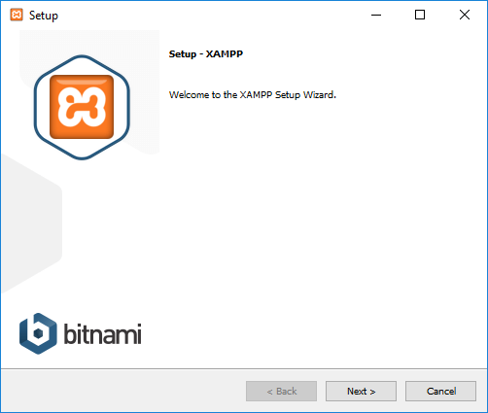

Figure 50

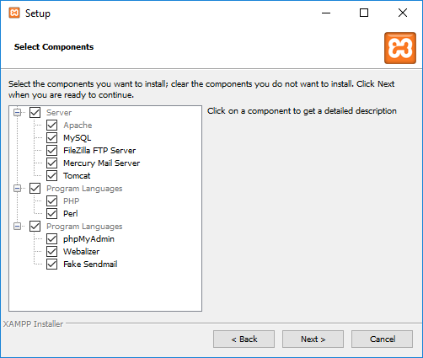

Figure 51

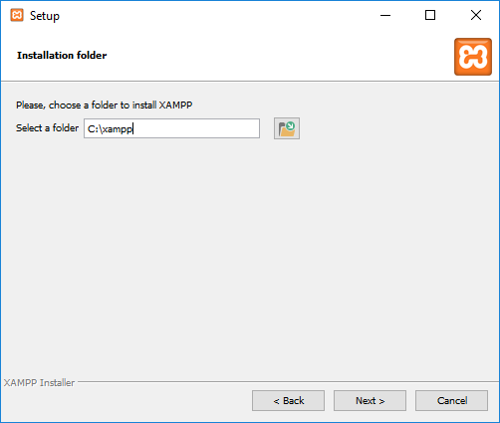

Figure 52

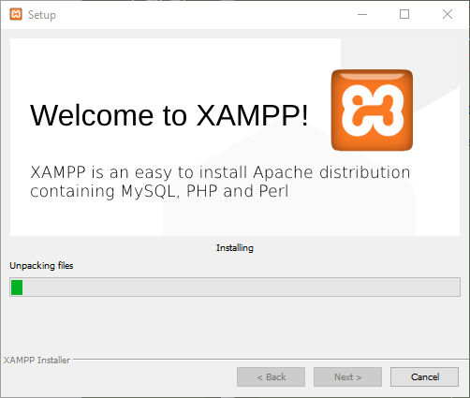

Figure 53

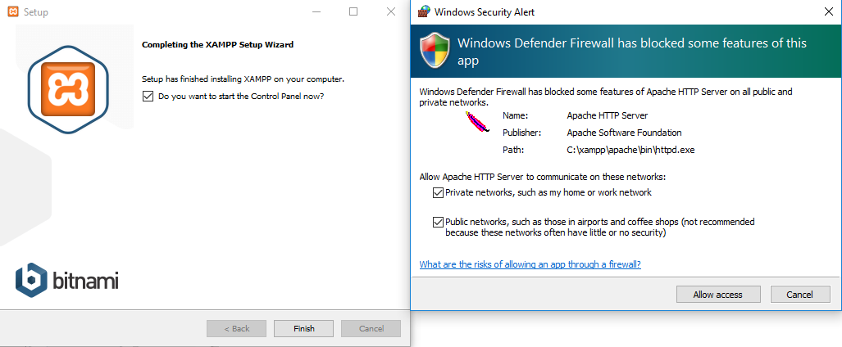

Figure 54

* Setting Up

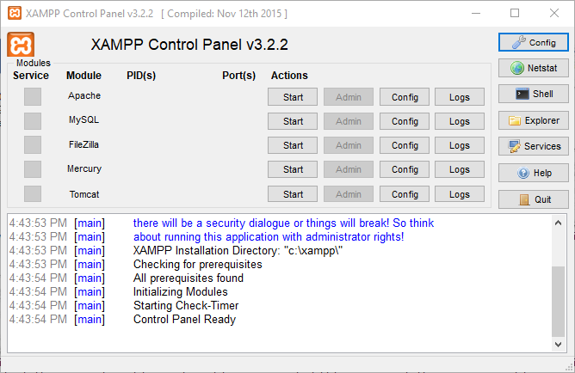

Figure 55

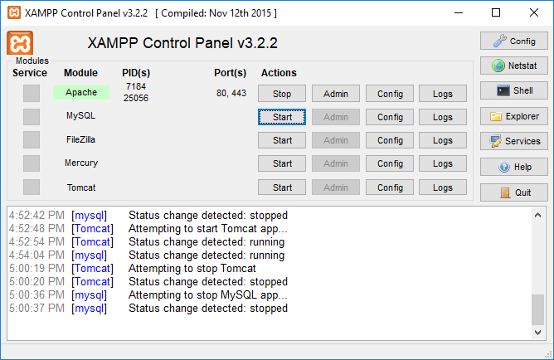

Figure 56

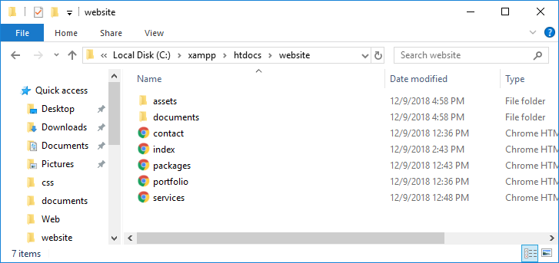

Figure 57

* Accessing local sever home web page

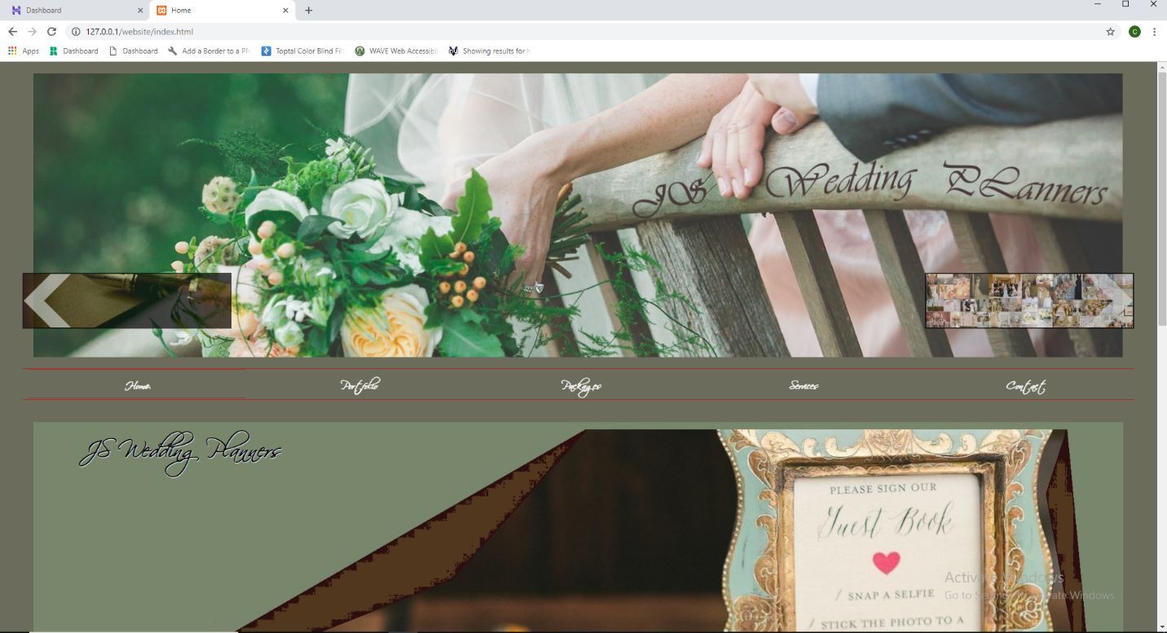

Figure 58

## Live hosting Deployment

* Setting up

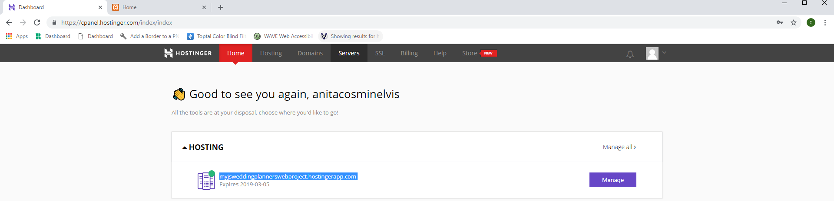

Figure 59

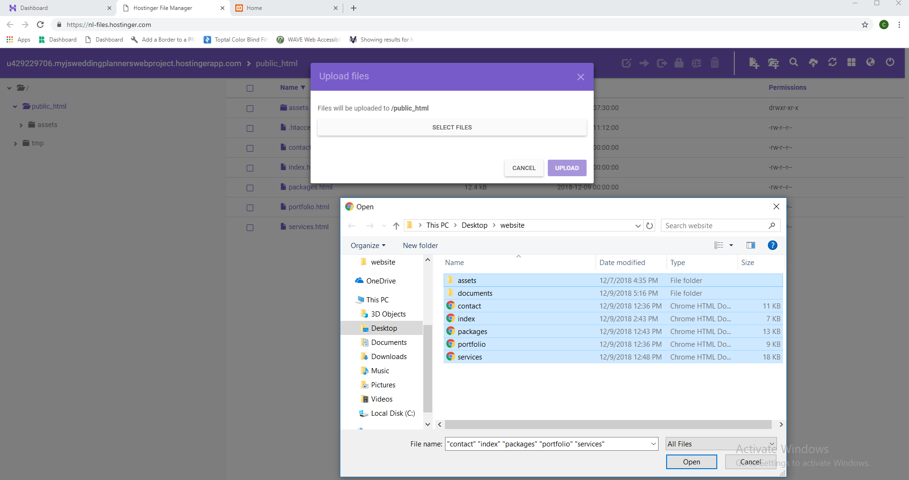

Figure 60

* Address - <http://myjsweddingplannerswebproject.hostingerapp.com/>
* Accessing web server’s home page

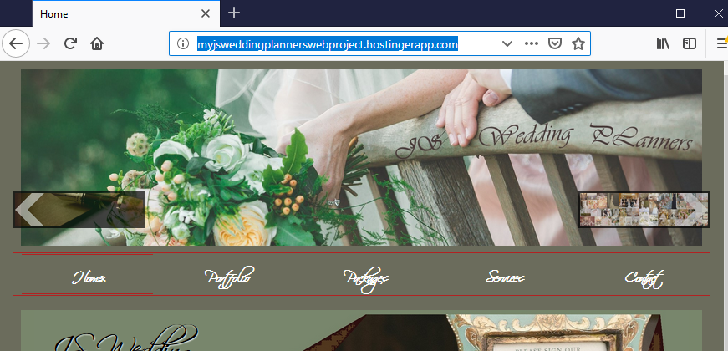

Figure 61

# Appendix A

* <http://myjsweddingplannerswebproject.hostingerapp.com/>
* 

# References

* Felke-Morris, Terry Ann. *Web Development and Design Foundations with HTML5.* 7th ed. Harlow: Pearson Education, 2015.
* Idler, S. (2013). Principles of Website Usability | 5 Key Principles of Good Website Usability. [online] The Daily Egg. Available at: http://blog.crazyegg.com/2013/03/26/principles-website-usability/ [Accessed 9 Jul. 2015].
* Responsive Web Design with HTML5 and CSS3 - Second Edition: Build responsive and future-proof websites to meet the demands of modern web users 2nd Edition
* <https://www.w3schools.com/>
* [www.coreservlets.com/html5-tutorial](http://www.coreservlets.com/html5-tutorial)
* <https://jigsaw.w3.org/css-validator/>
* <https://validator.w3.org/>
* <https://caniuse.com/>